School Name
Mathematics Test 2017
Year 9 |  | Pythagoras Theorem | Calculator Allowed
Skills and Knowledge Assessed:  - Investigate Pythagoras’ Theorem and its application to solving simple problems involving right angled triangles (ACMMG222)  - Investigate the concept of irrational numbers, including π (ACMMG186) |  |  | Name_________________
Section 1 Short Answer Section
Write all working and answers in the spaces provided on this test paper.

Name the hypotenuse of the right triangle EFG?
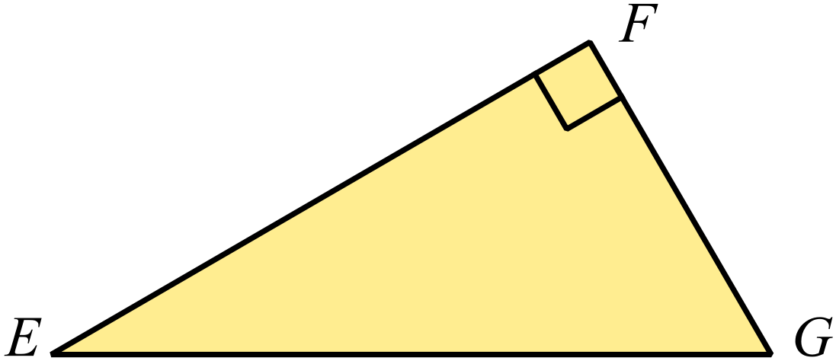

………………………………………………
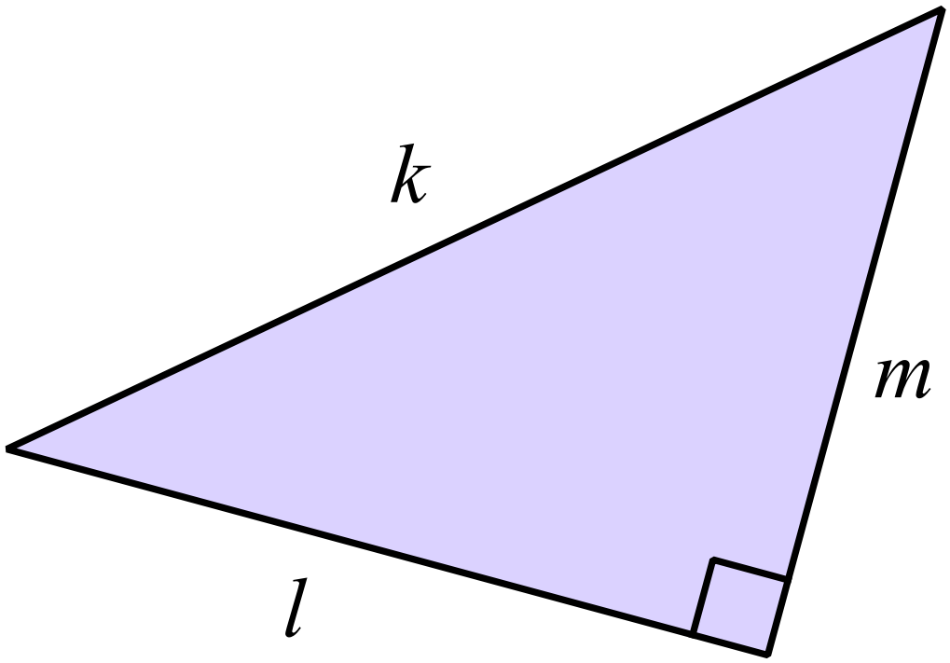Write a statement of Pythagoras Theorem for the triangle shown below.

…………………………………………………

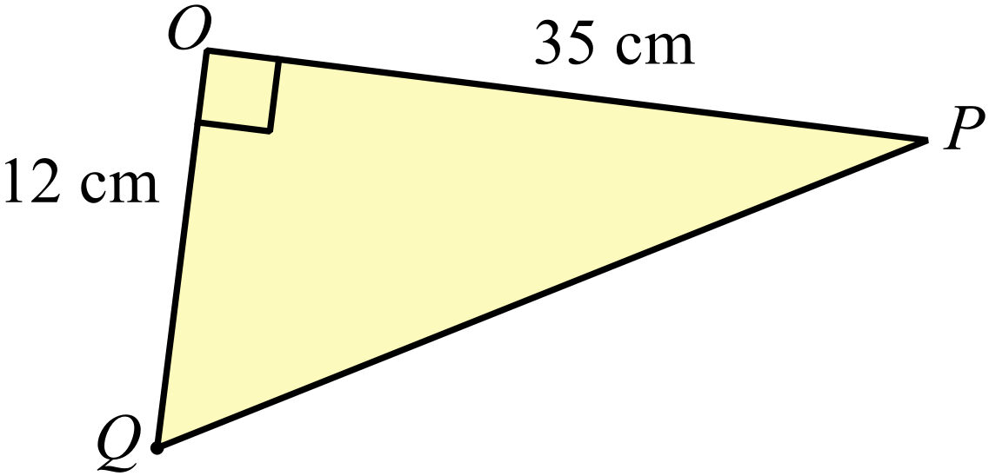Find the length of PQ.

…………………………………………....

…………………………………………....

……………………………………………

…………………………………………….
Find the value of c in the triangle below.
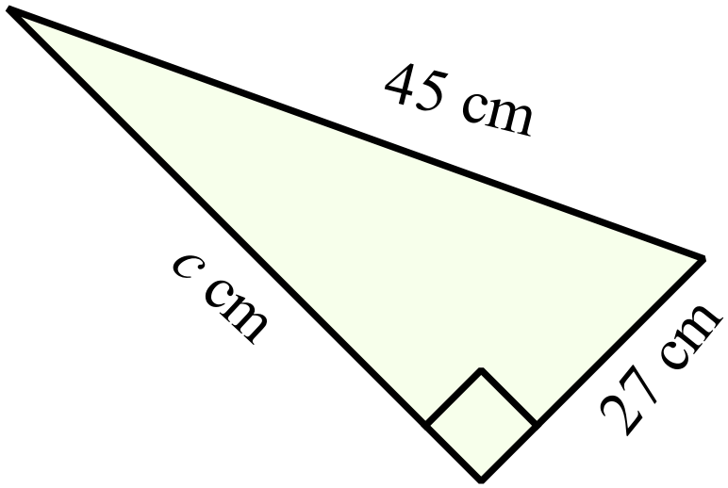
………………………………………………

……………………………………………....

………………………………………………

……………………………………………….
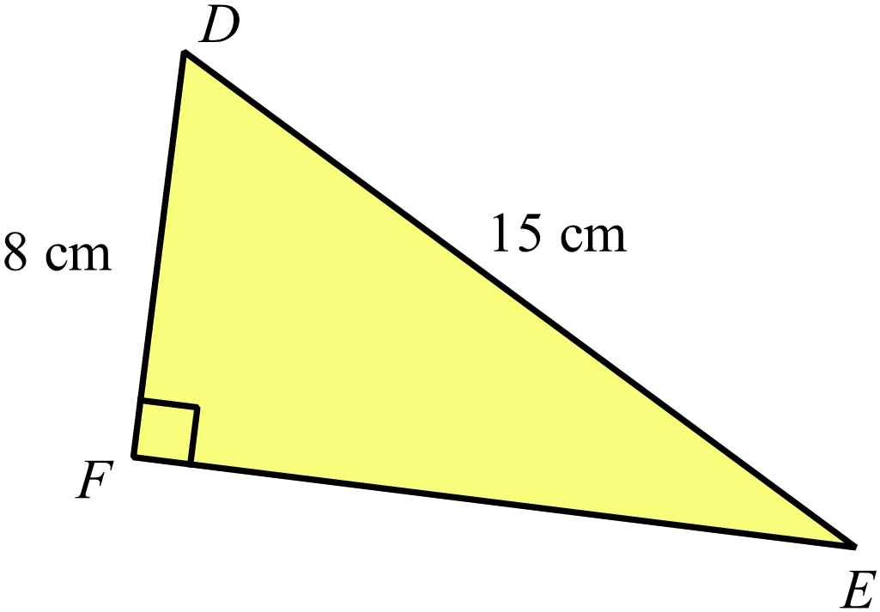Calculate the length of EF, correct to one decimal place.

……………………………………………

…………………………………………....

……………………………………………

…………………………………………….
Which of the following sets could be described as a Pythagorean triad? (Show why.)
Set A {21, 72, 75} Set B {42, 60, 75}.

……………………………………………………………………………………………....

……………………………………………………………………………………………….
A rectangle is 64 cm long and has a diagonal which is 80 cm long.
Calculate the width of the rectangle.

……………………………………………………………………………………………....

……………………………………………………………………………………………….
Determine if the triangle below is right angled?
Use calculations to support your decision.
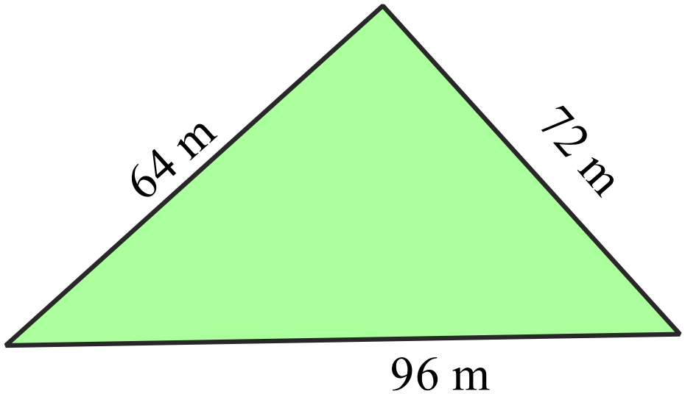
………………………………………………

……………………………………………....

………………………………………………

……………………………………………….
Calculate the exact value of x.
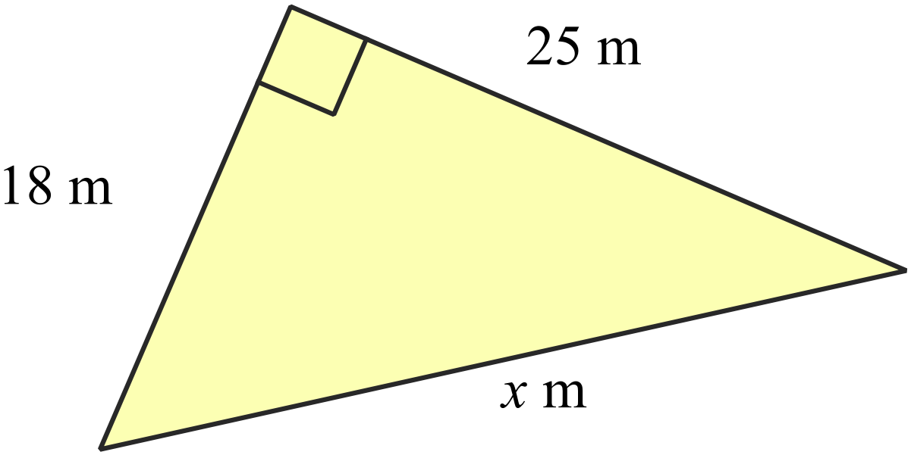

………………………………………………

……………………………………………....

………………………………………………

……………………………………………….
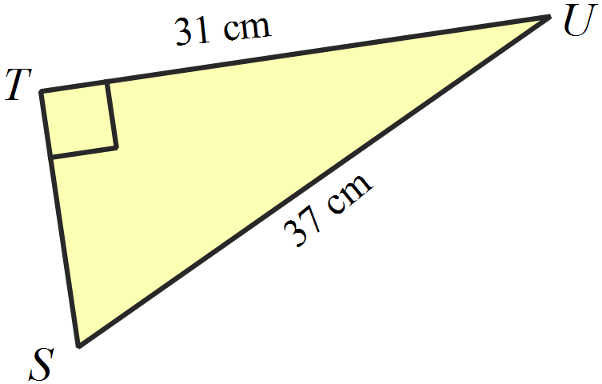What is the length of ST, correct to 1 decimal place?

………………………………………………

……………………………………………....

………………………………………………

……………………………………………….
What is the perimeter of the triangle XYZ?
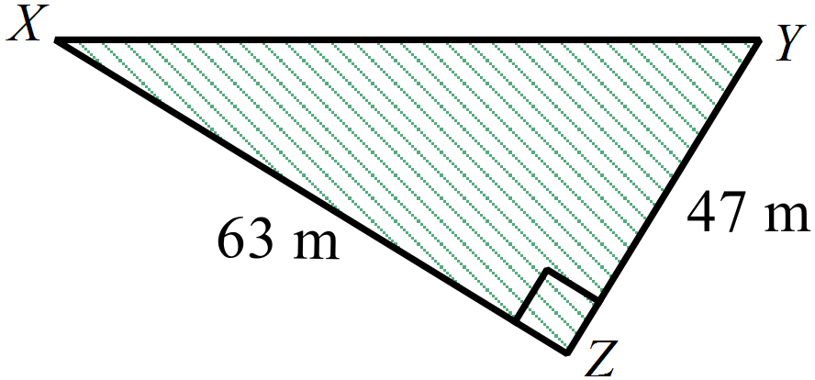(Answer correct to the nearest 10th of a square metre.)
………………………………………………

……………………………………………....

………………………………………………

……………………………………………….
What is the area of the triangle PQR?
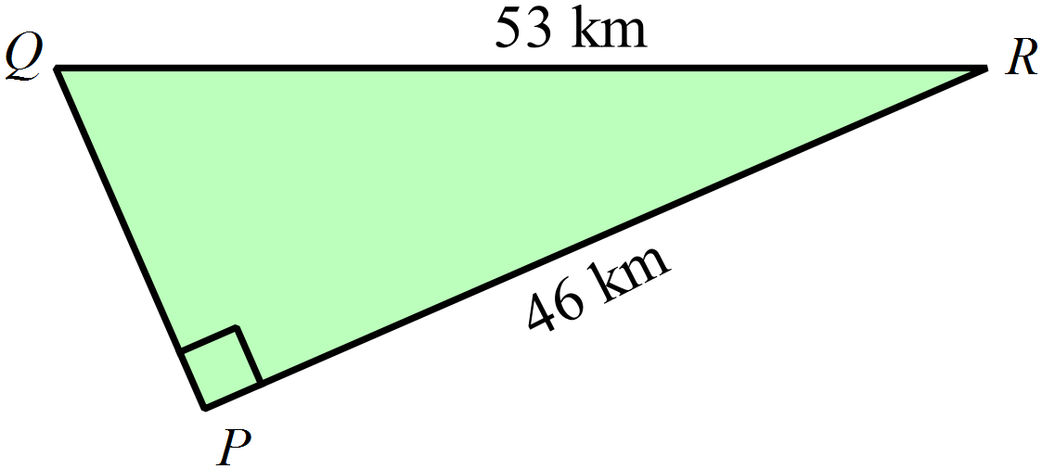(Answer correct to 1 decimal place.)
………………………………………………

……………………………………………....

………………………………………………

……………………………………………….
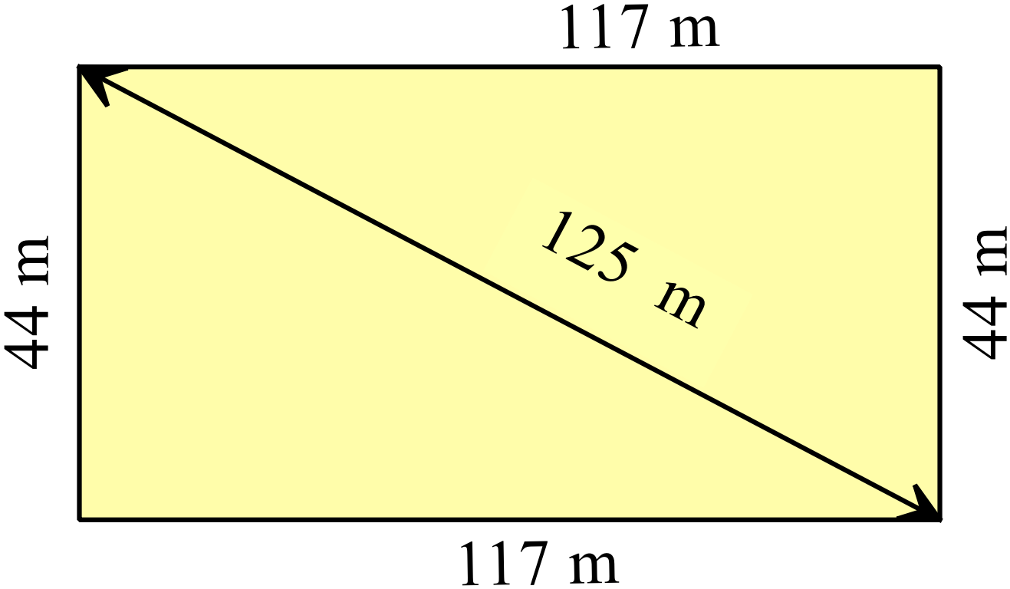Determine if the quadrilateral shown is a rectangle.

………………………………………………

……………………………………………....

………………………………………………

……………………………………………….
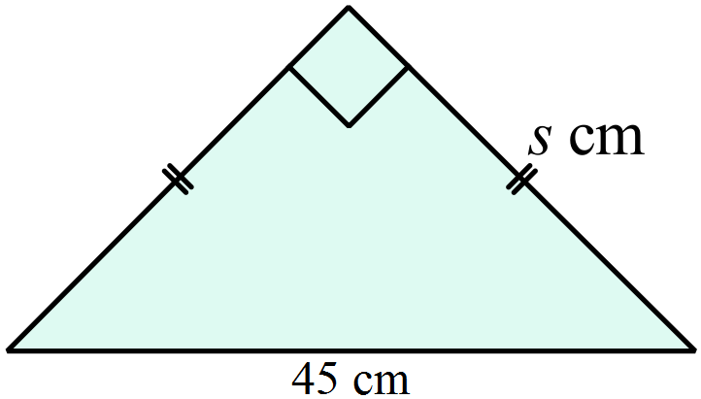A right isosceles triangle is shown.
What is the value of s, correct to 1 decimal place?

………………………………………………

……………………………………………....

………………………………………………

……………………………………………….
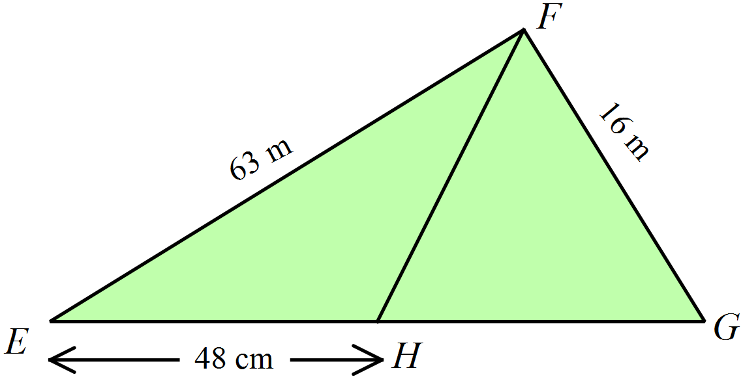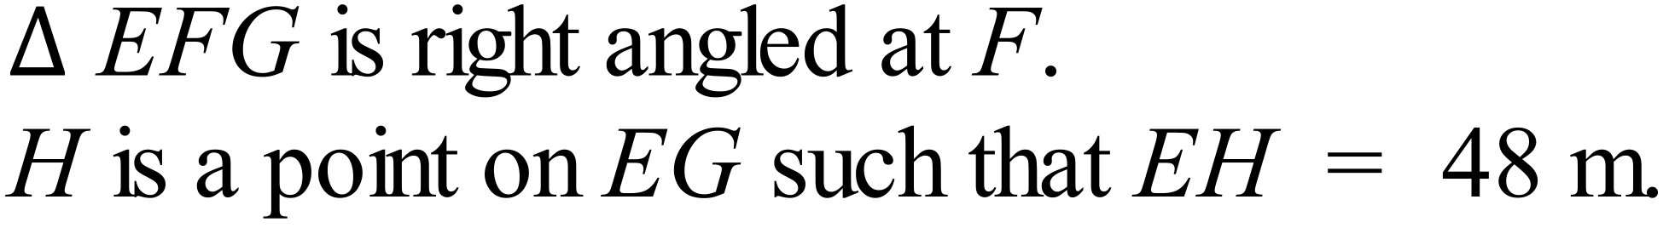
Find the length of HG.

………………………………………………

……………………………………………....

………………………………………………

……………………………………………….

School Name
Mathematics Test 2017
Year 9 |  | Pythagoras Theorem | Calculator Allowed
 |  | Pythagoras Theorem | Name_________________
Section 2 Multiple Choice Section
Mark all your answers on the accompanying multiple choice answer sheet, not on this test paper. You may do any working out on this test paper. Calculators are allowed for this section.

Which is a correct statement of Pythagoras Theorem for the triangle shown below.
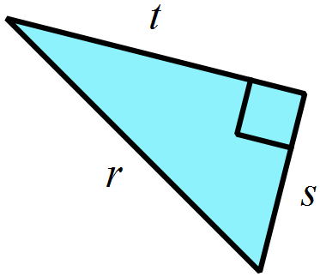
A. 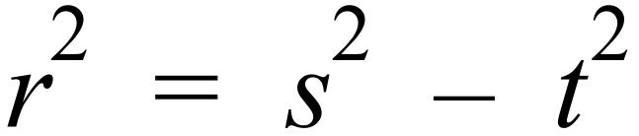
B. 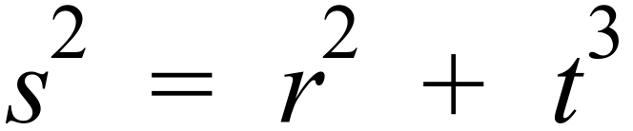
C. 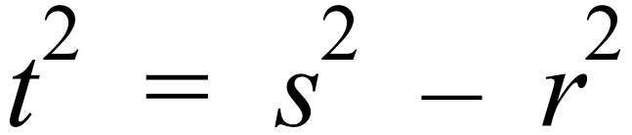
D. 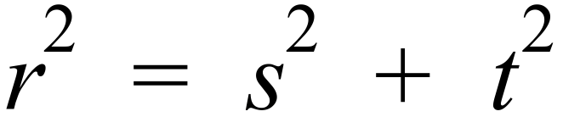

Find the value of x.
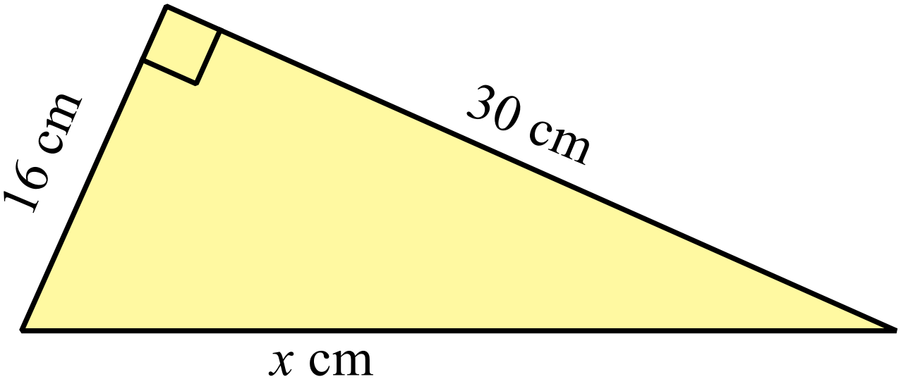
A. x = 25
B. x = 31
C. x = 34
D. x = 46

Find the value of y.
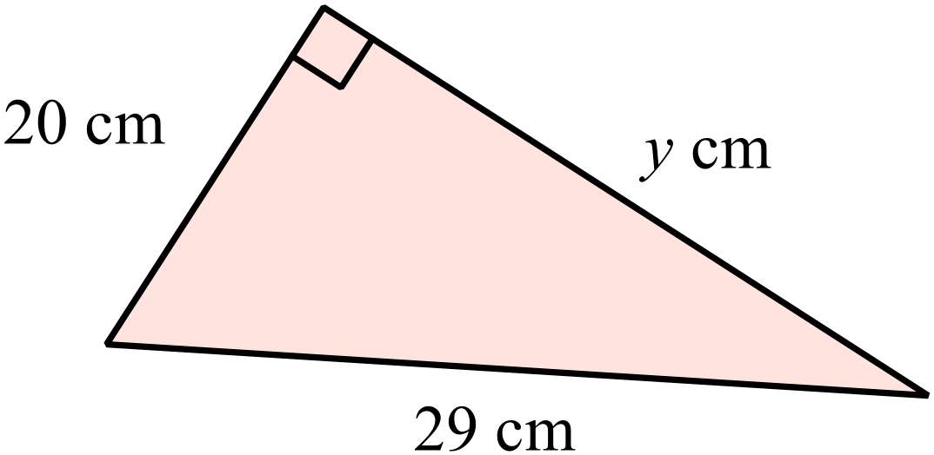
A. y = 9
B. y = 21
C. y = 25
D. y = 35

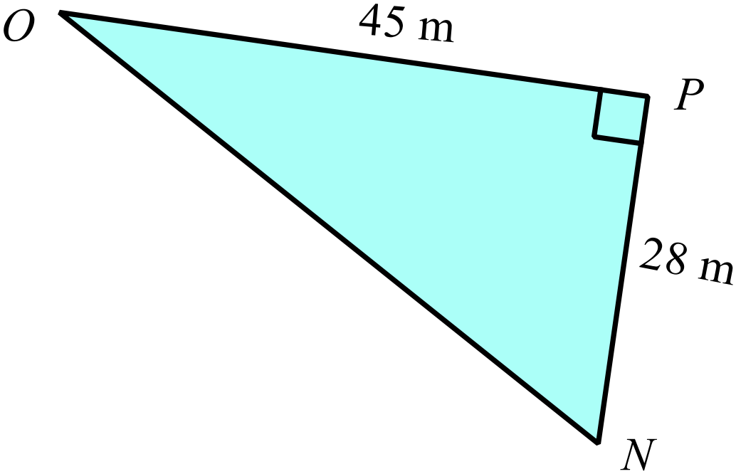What is the length of ON ?

A. 48 m
B. 53 m
C. 61 m
D. 73 m

Find the distance XZ to the nearest millimetre.
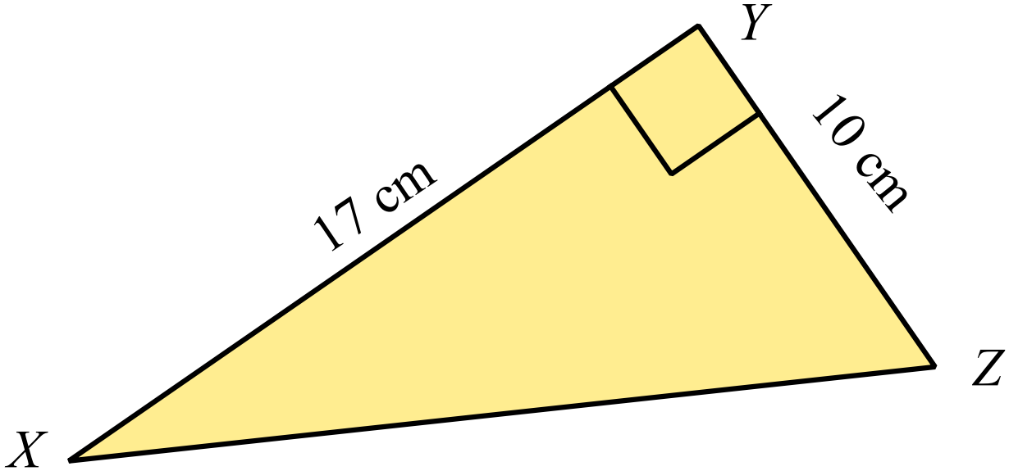

A. 19.7 cm
B. 20.3 cm
C. 23.5 cm
D. 27.0 cm

Find the length of KI (leave your answer as a surd).
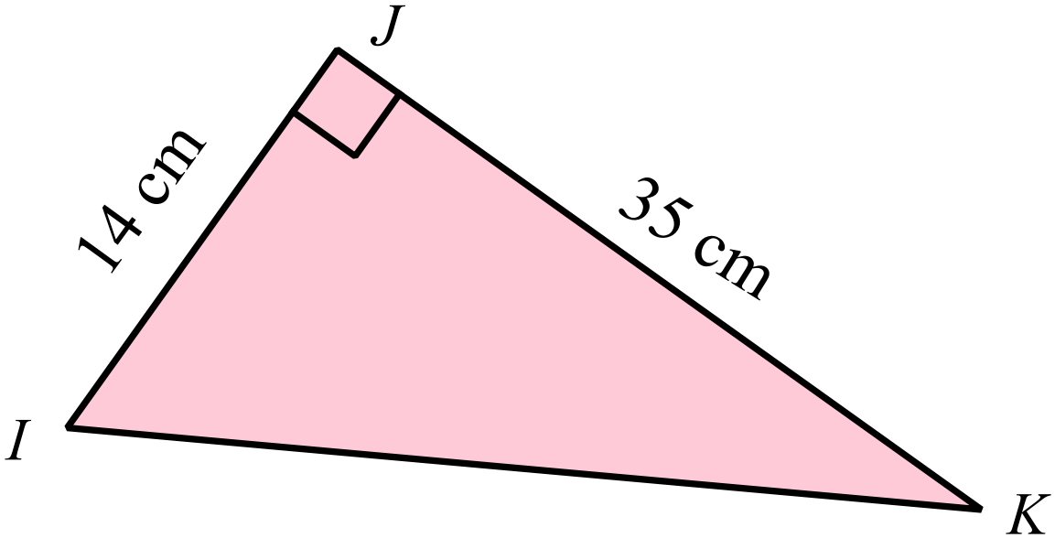

A. 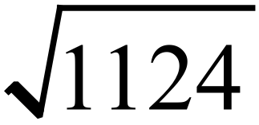
B. 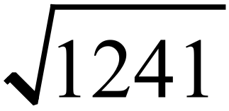
C. 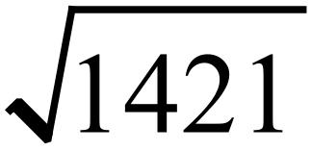
D. 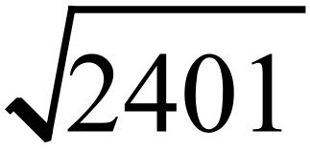

Determine if either of the triangles shown are right angled.
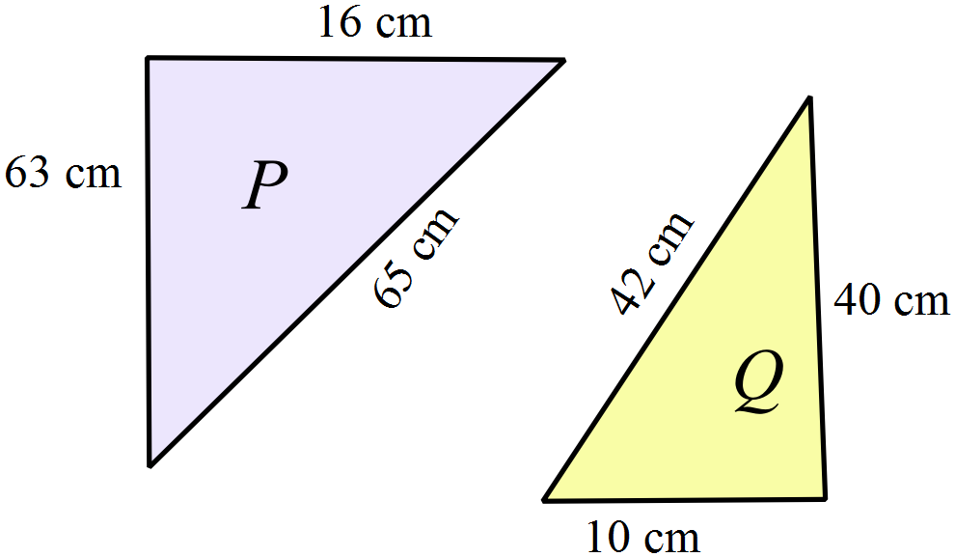

A. Both triangles are right angled.
B. Neither triangle is right angled.
C. Only triangle P is right angled.
D. Only triangle Q is right angled.

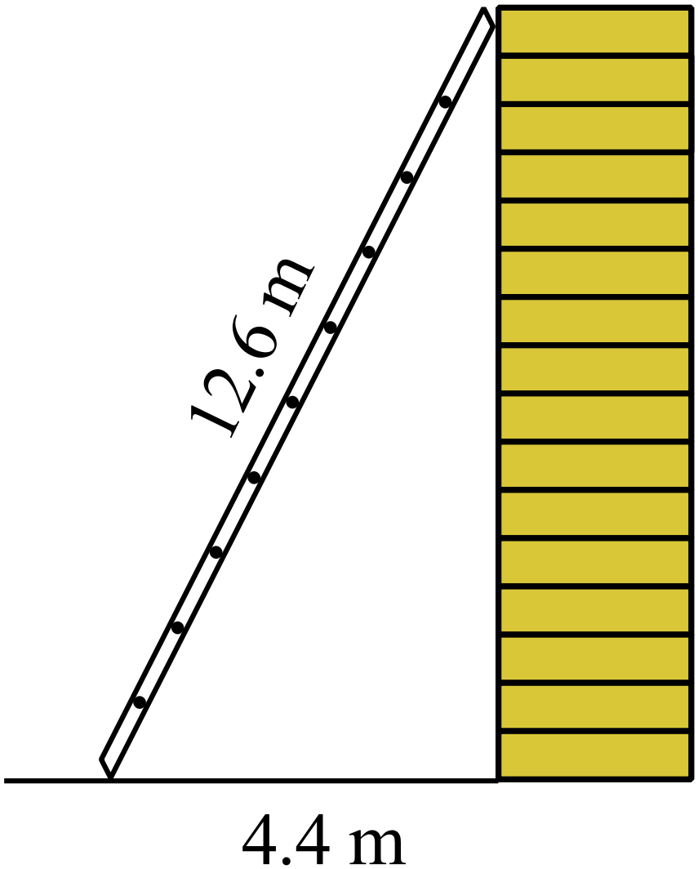The ladder shown, leans against the top of the wall.
What is the height of the wall, correct to the nearest 10th of a metre?

A. 11.8 m
B. 12.1 m
C. 12.4 m
D. 13.3 m

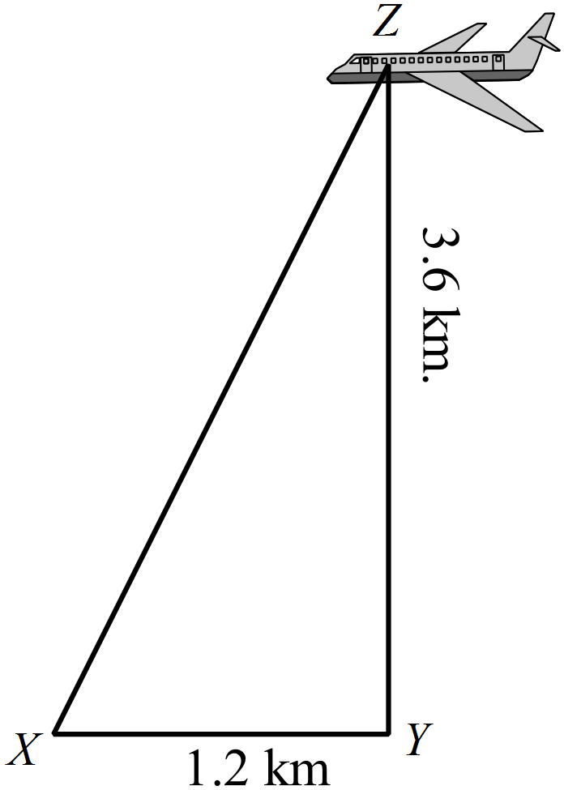A plane (Z) is 3.6 km directly above a point Y.
It is viewed from point X, which is 1.2 km horizontally from Y.
What is the distance XZ (to the nearest 10 m)?
A. 3.69 km
B. 3.79 km
C. 3.95 km
D. 4.65 km

Are either or both of the following two sets of numbers, Pythagorean triads?

Set A (48, 55, 73)
Set B (11, 60, 61)

A. Both sets are Pythagorean triads.
B. Neither set is a Pythagorean triads.
C. Only Set A is a Pythagorean triad.
D. Only Set B is a Pythagorean triad.

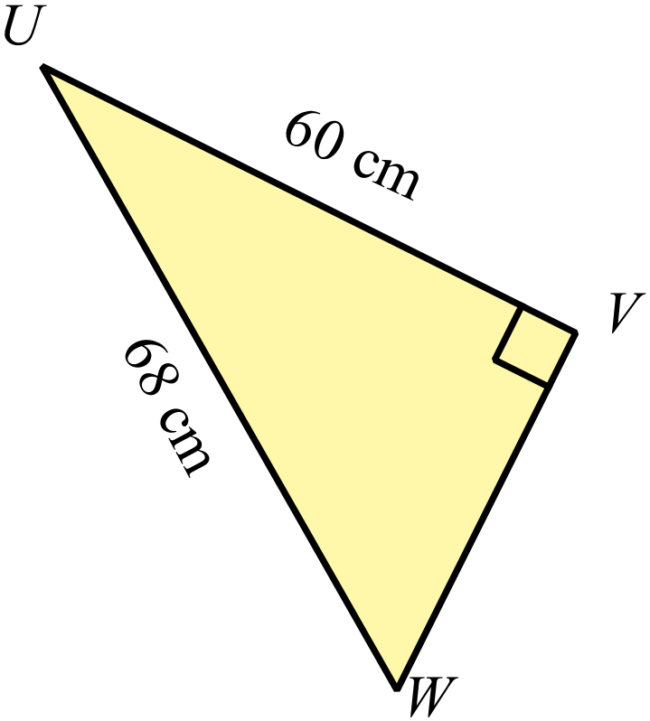Find the area of 

A. 510 cm²
B. 680 cm²
C. 720 cm²
D. 960 cm²

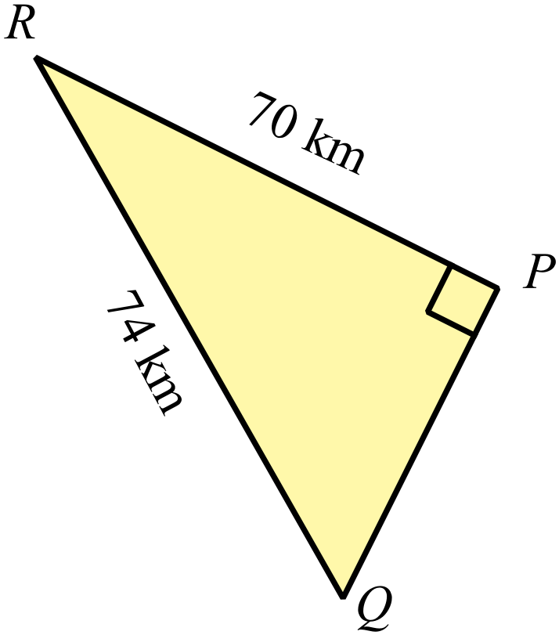What is the perimeter of the triangle PQR?

A. 144 cm
B. 152 cm
C. 158 cm
D. 168 cm

BC = 34 cm, AB = 20 cm and BD = 16 cm.
Calculate the distance AC.
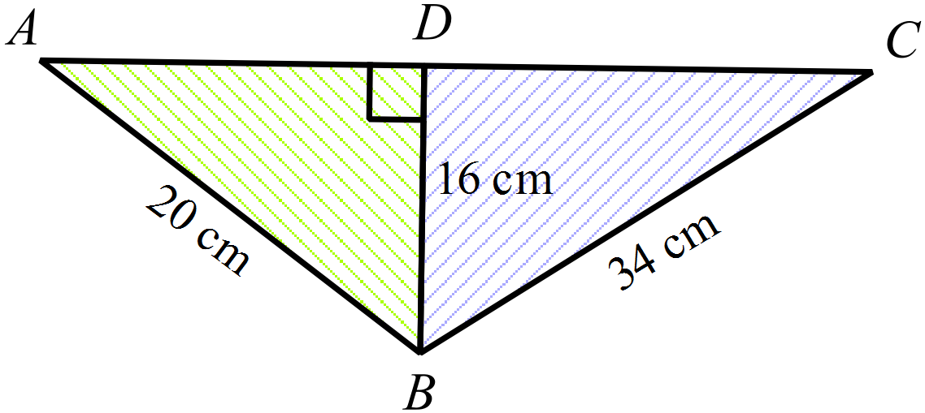

A. 27 cm
B. 30 cm
C. 42 cm
D. 54 cm

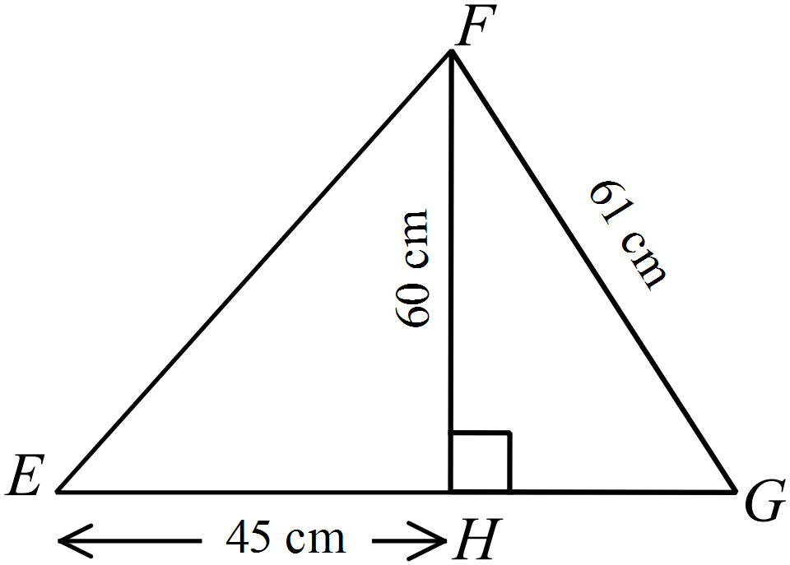Also EH = 45 cm, FH = 60 cm and FG = 61 cm.
Find the perimeter of  .

A. 166 cm
B. 192 cm
C. 198 cm
D. 206 cm

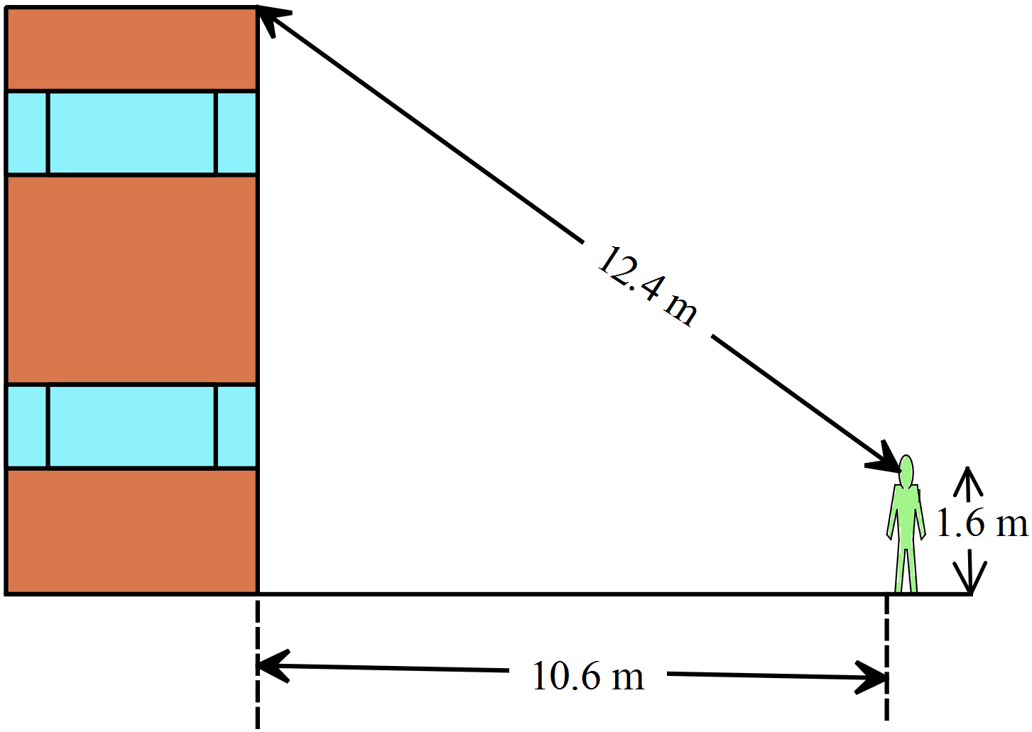From 10.6 metres away from the base of a building, Karen sites the direct distance to the top of the building to be 12.4 m.

If her eye level is 1.6 m above ground, calculate the height of the building, to the nearest 10th of a metre.

A. 3.4 m
B. 6.4 m
C. 7.4 m
D. 8.0 m

School Name
Mathematics 2017
Multiple Choice Answer Sheet
Pythagoras Theorem
Name _____________________________________________
Completely fill the response oval representing the most correct answer.
1. A B C D
2. A B C D
3. A B C D
4. A B C D
5. A B C D
6. A B C D
7. A B C D
8. A B C D
9. A B C D
10. A B C D
11. A B C D
12. A B C D
13. A B C D
14. A B C D
15. A B C D

School Name
Mathematics Test 2017
Year 9 | Pythagoras Theorem | Non Calculator Section
ANSWERS

Question | Working and Answer
 | EG is the longest side and opposite to the right angle, so EG is the hypotenuse.
 | k is the hypotenuse so 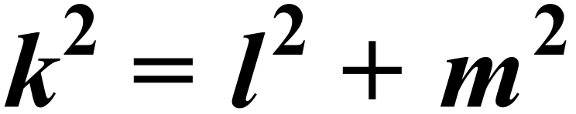
 | 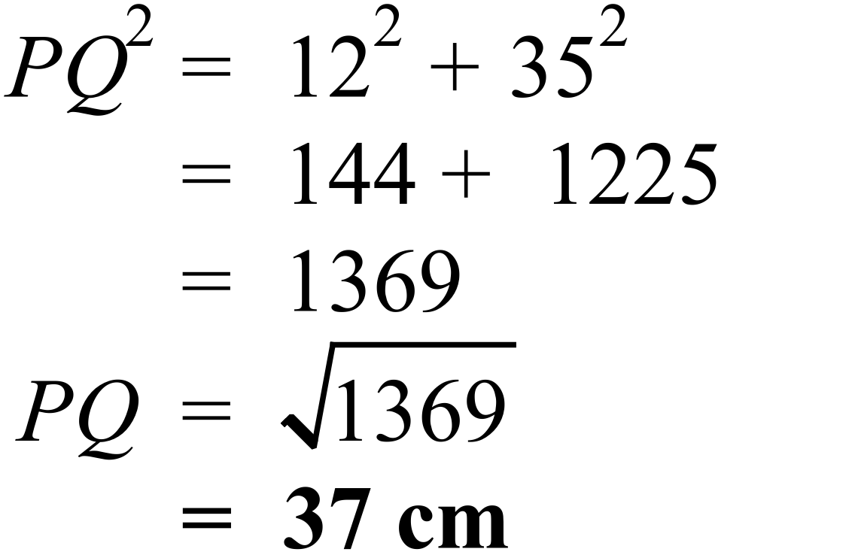
 | 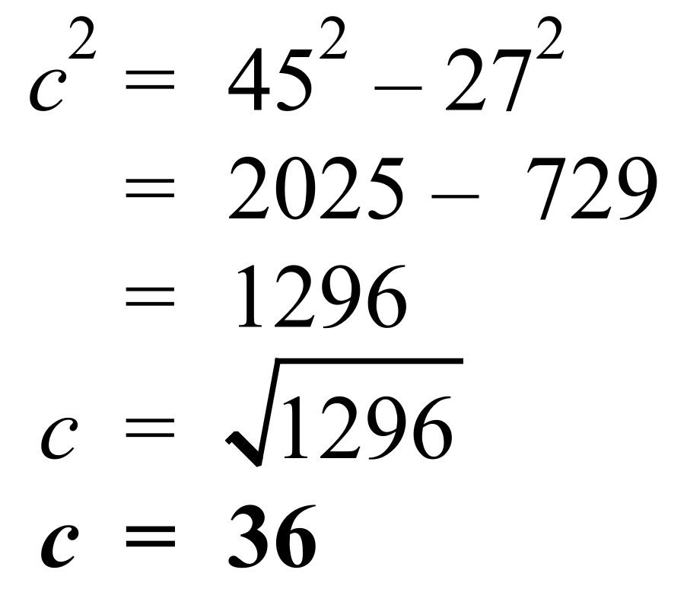
 | 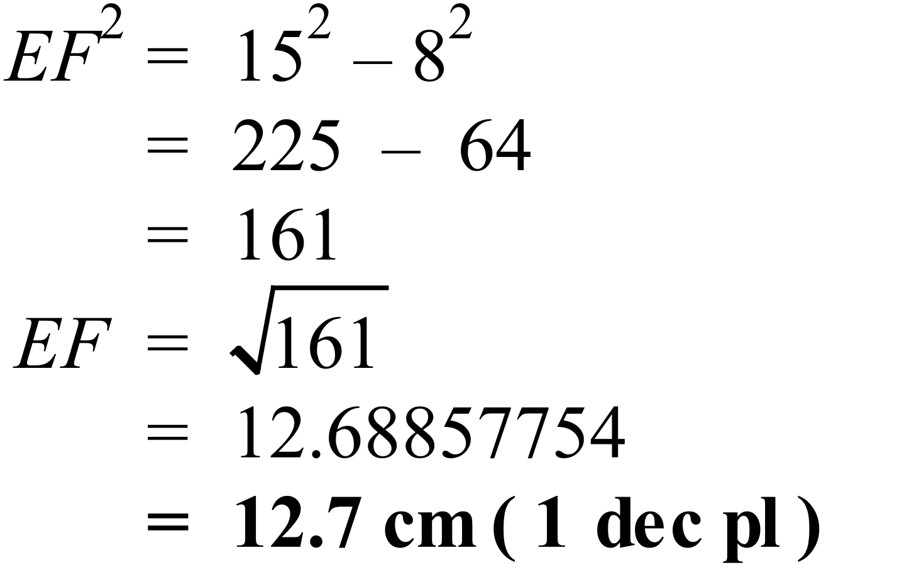
 | 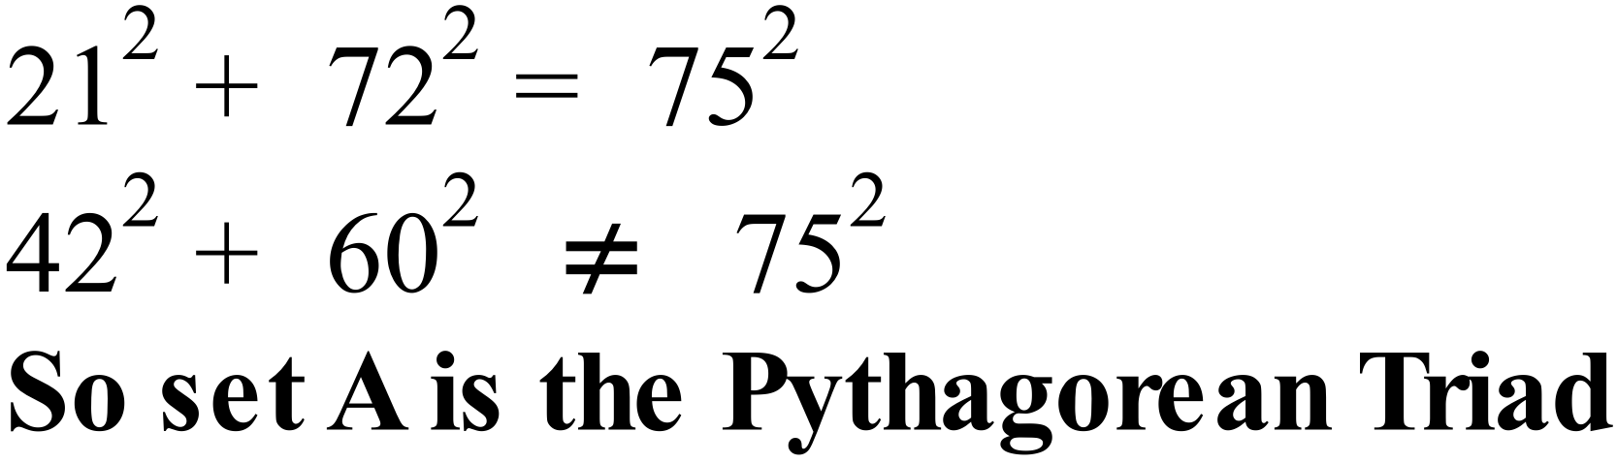
 | 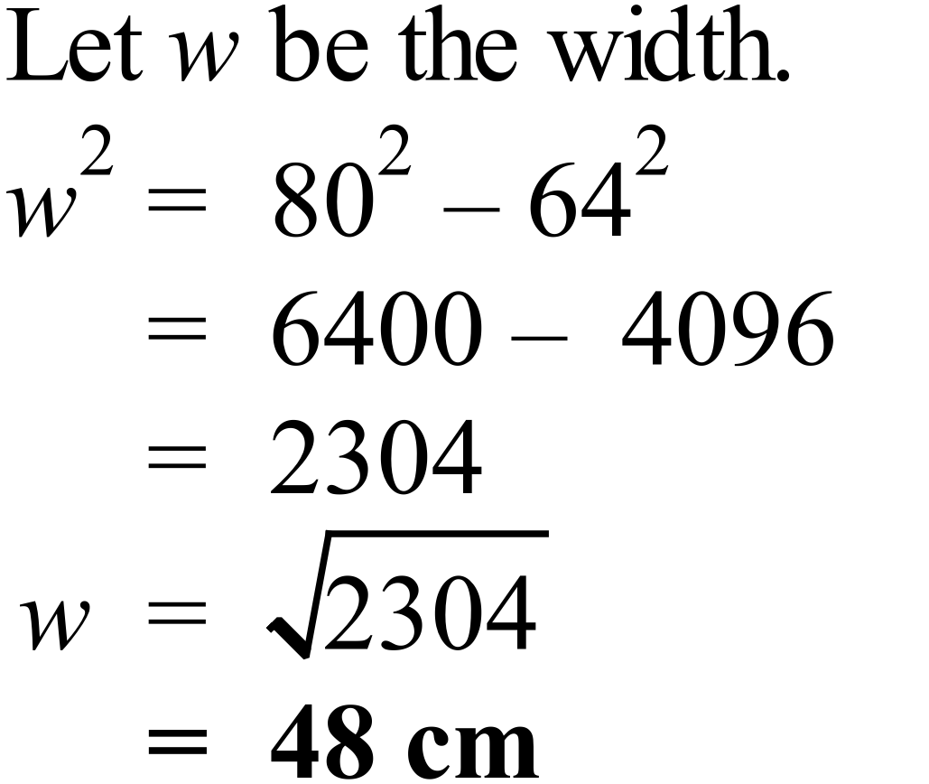
 | 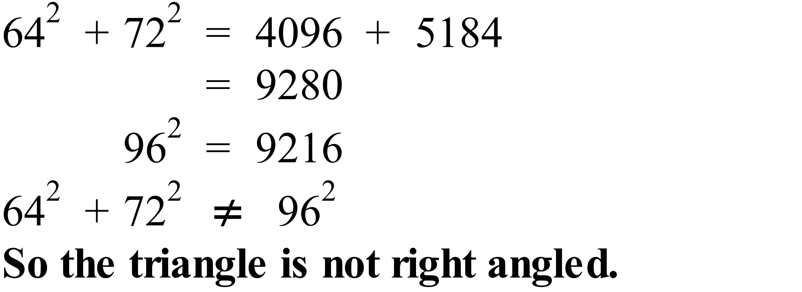
 | 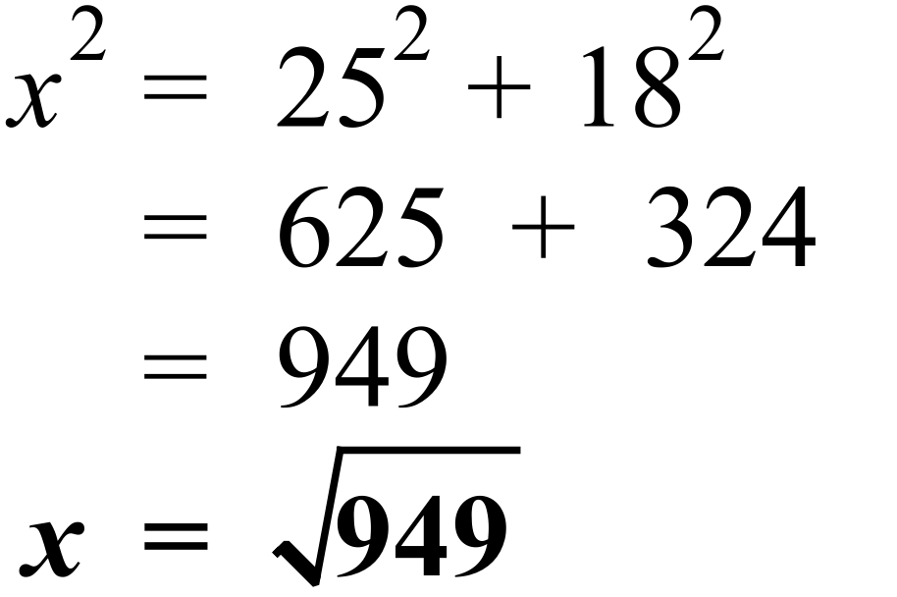
 | 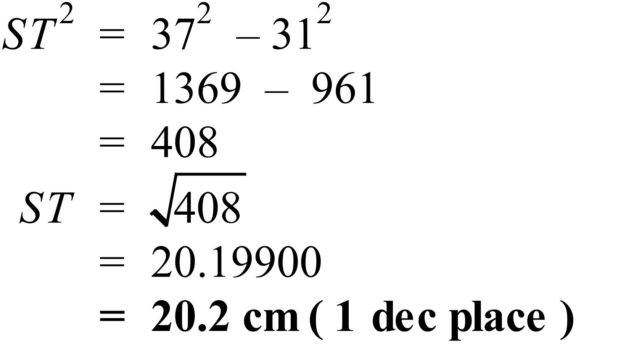
 | 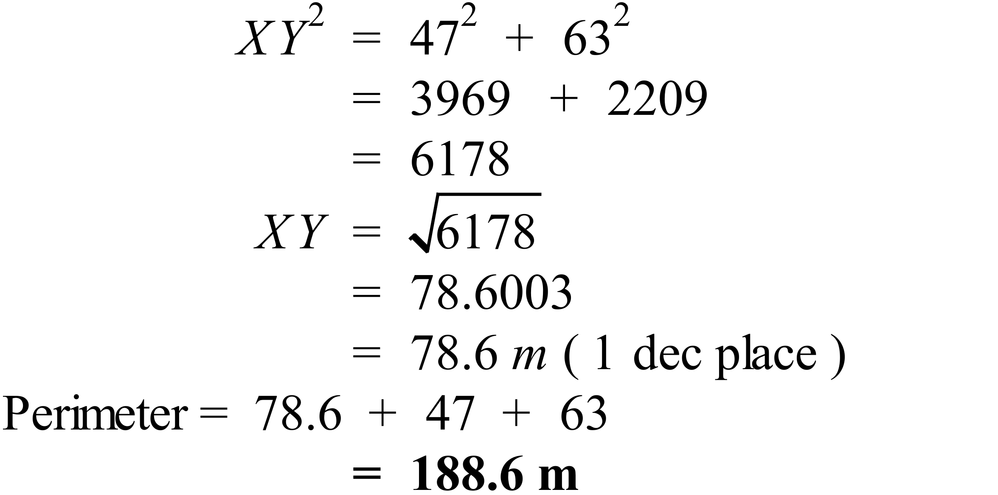
 | 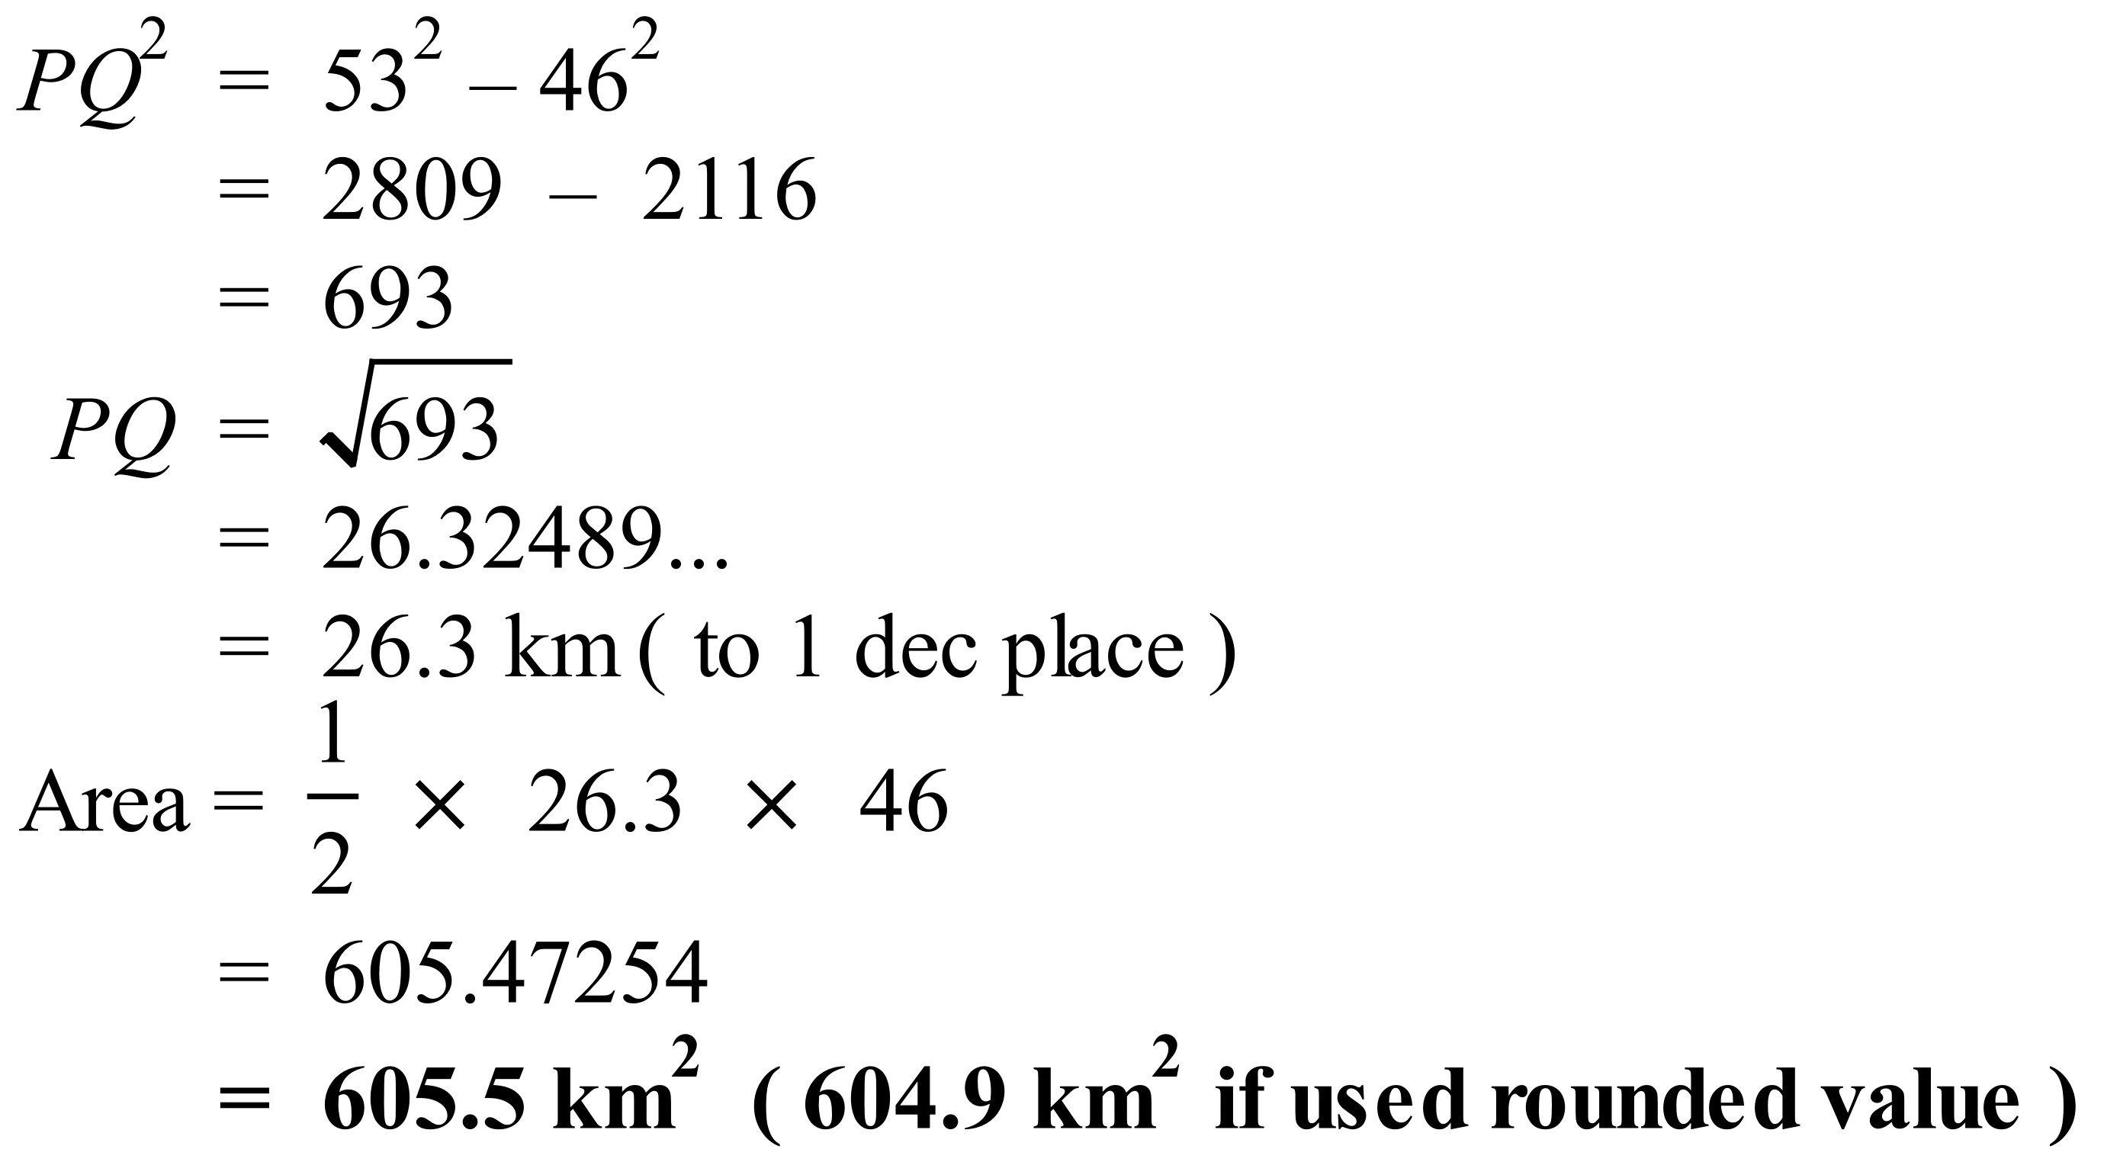
 | 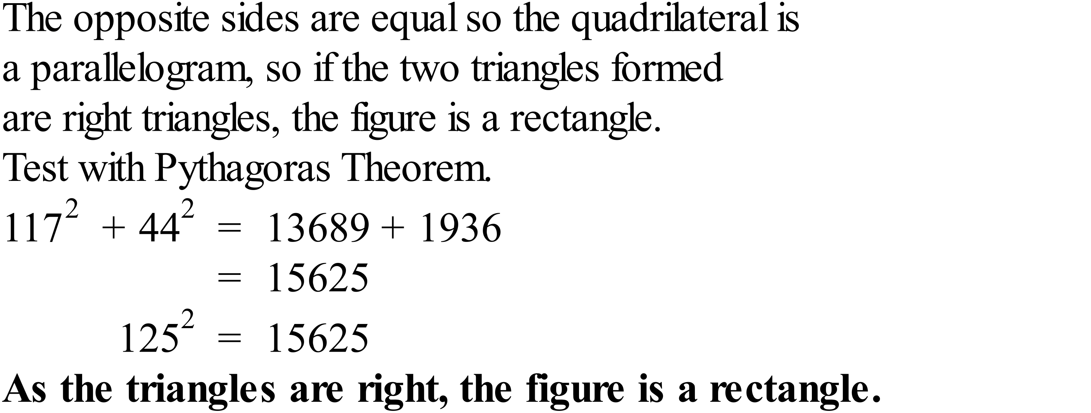
 | 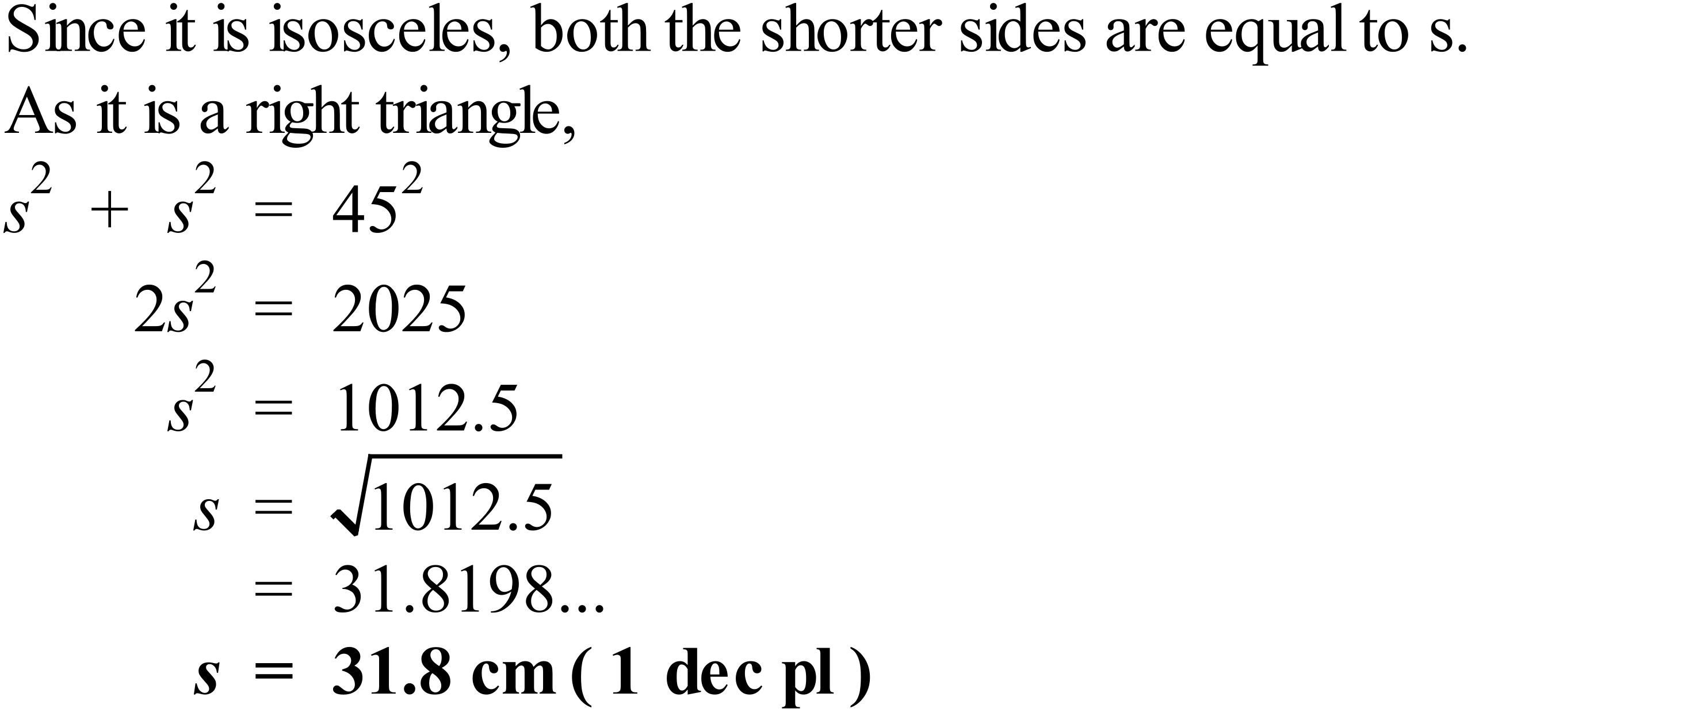
 | 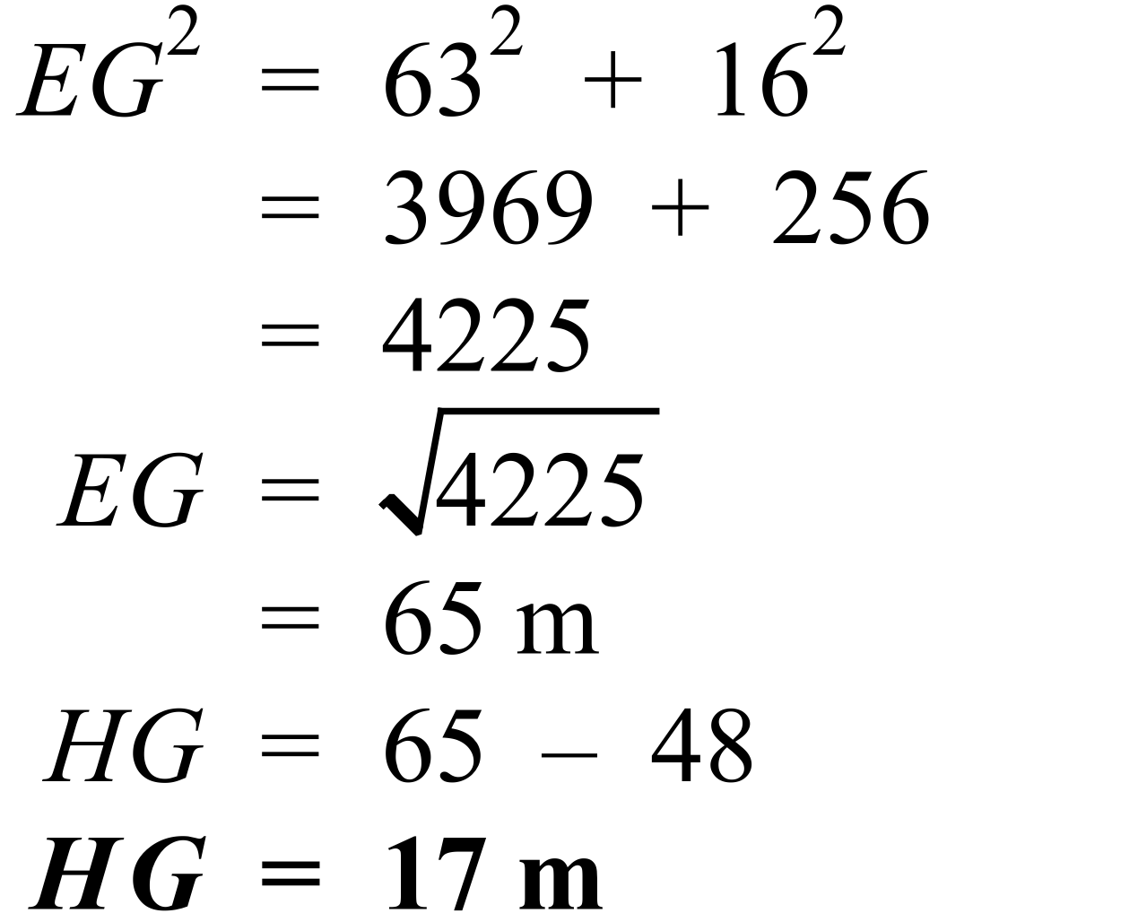

School Name
Mathematics Test 2017
Year 9 | Pythagoras Theorem | Calculator Allowed  Multiple Choice  Section

ANSWERS

Question | Working | M C Answer
 | 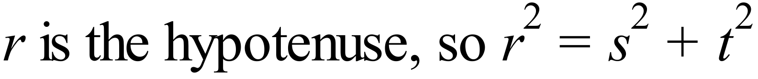 | D
 | 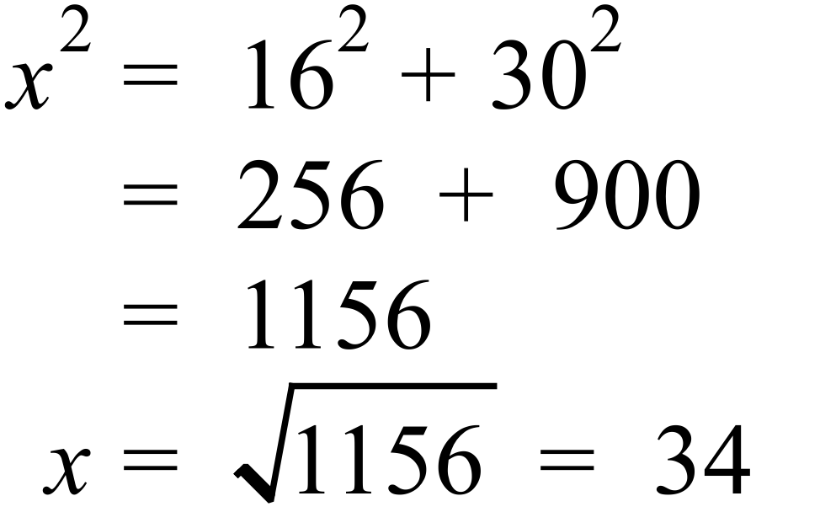 | C
 | 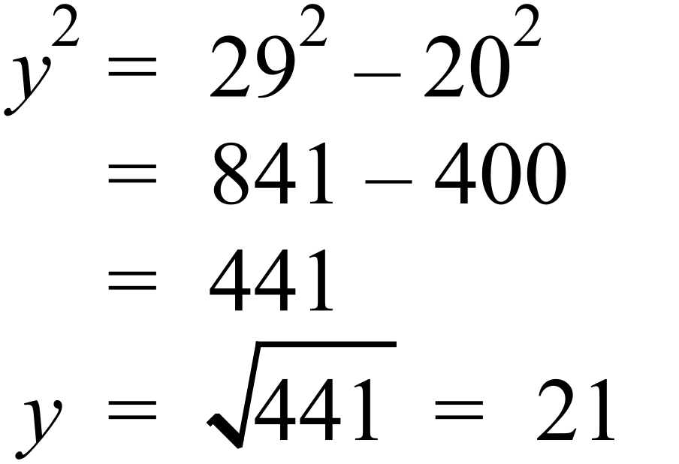 | B
 | 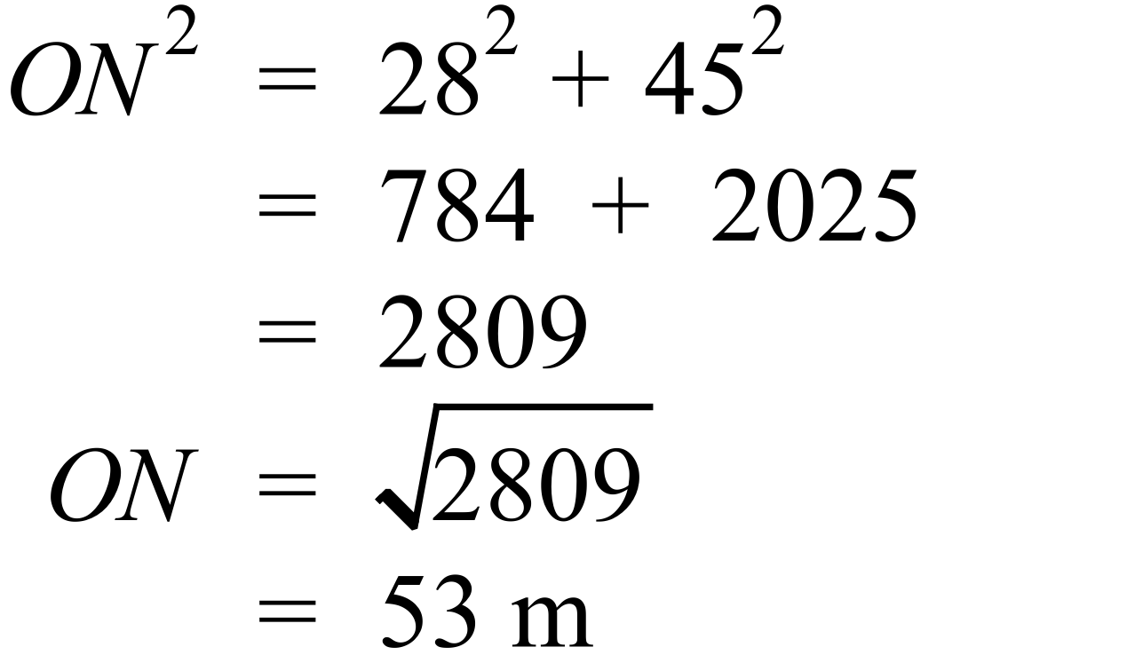 | B
 | 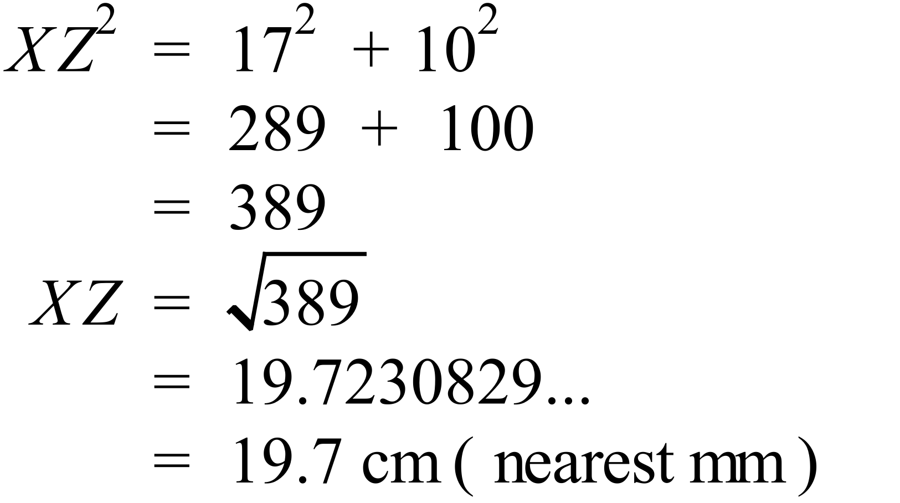 | A
 | 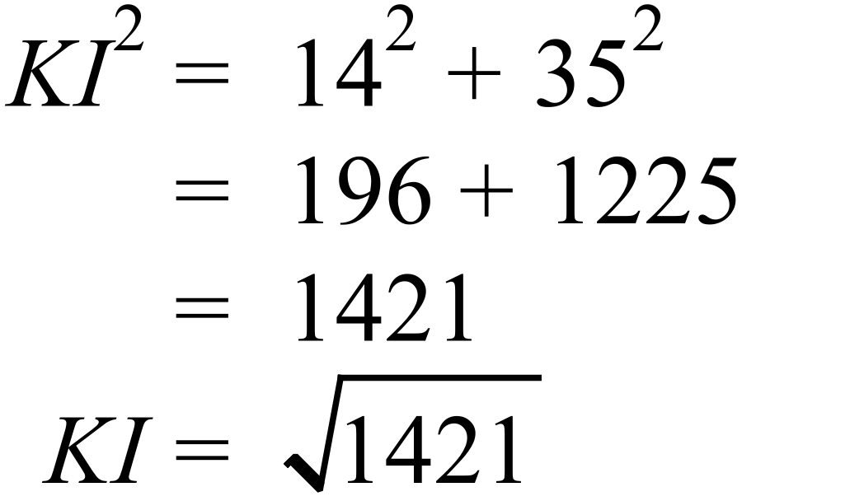 | C
 | 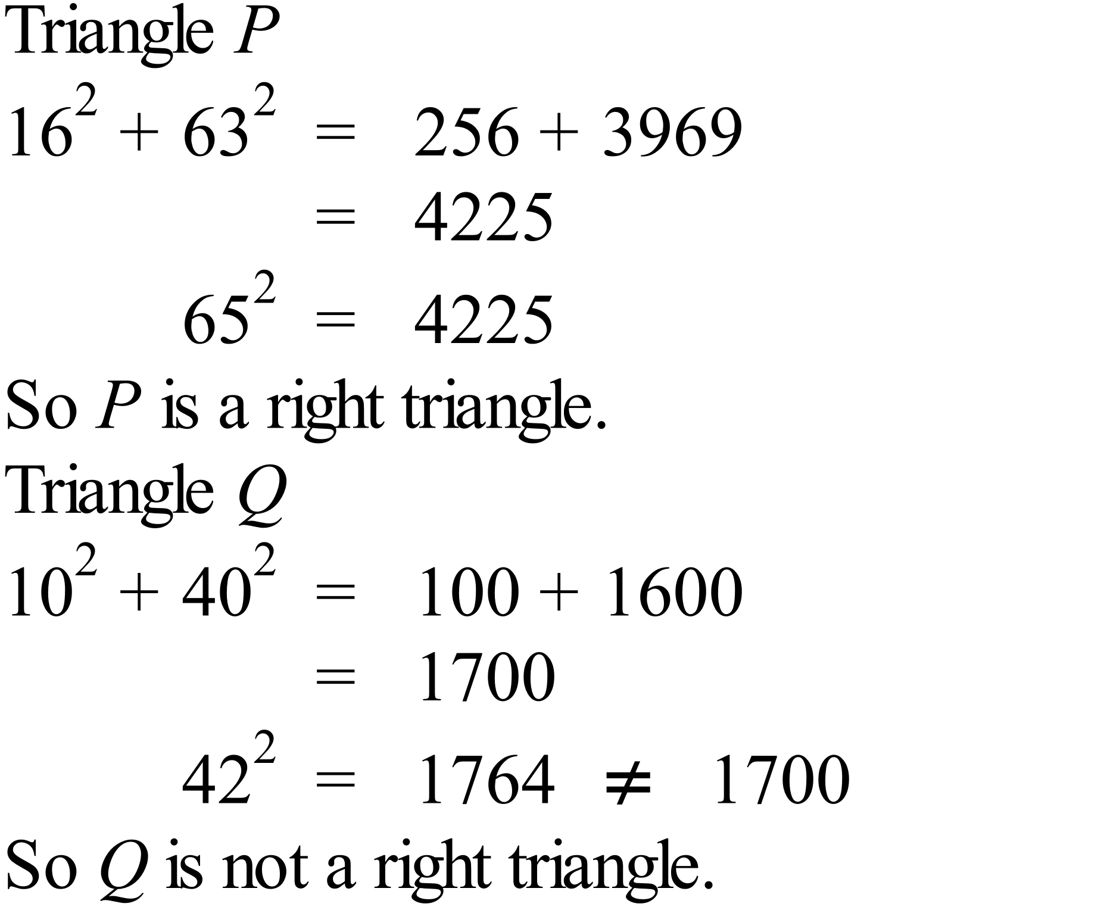 | C
 | 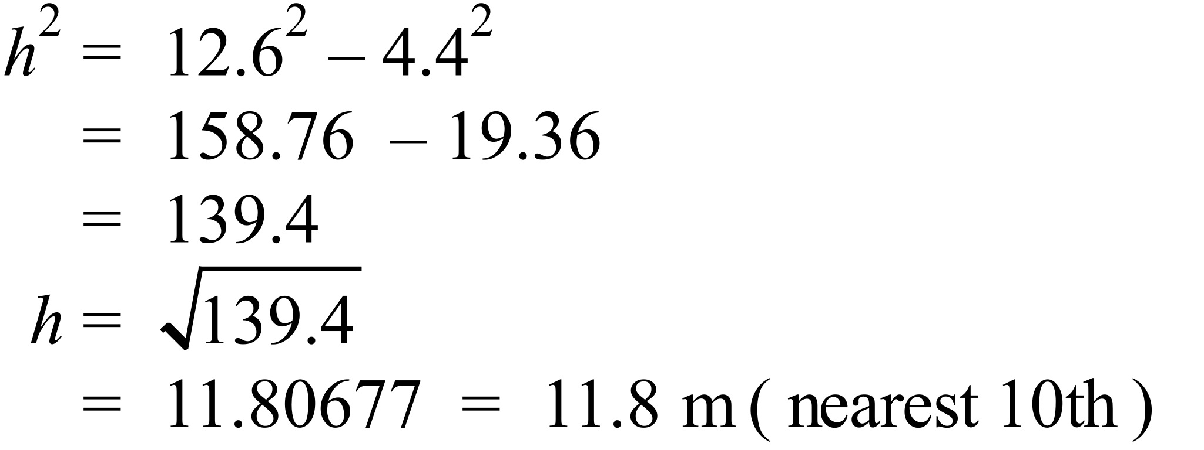 | A
 | 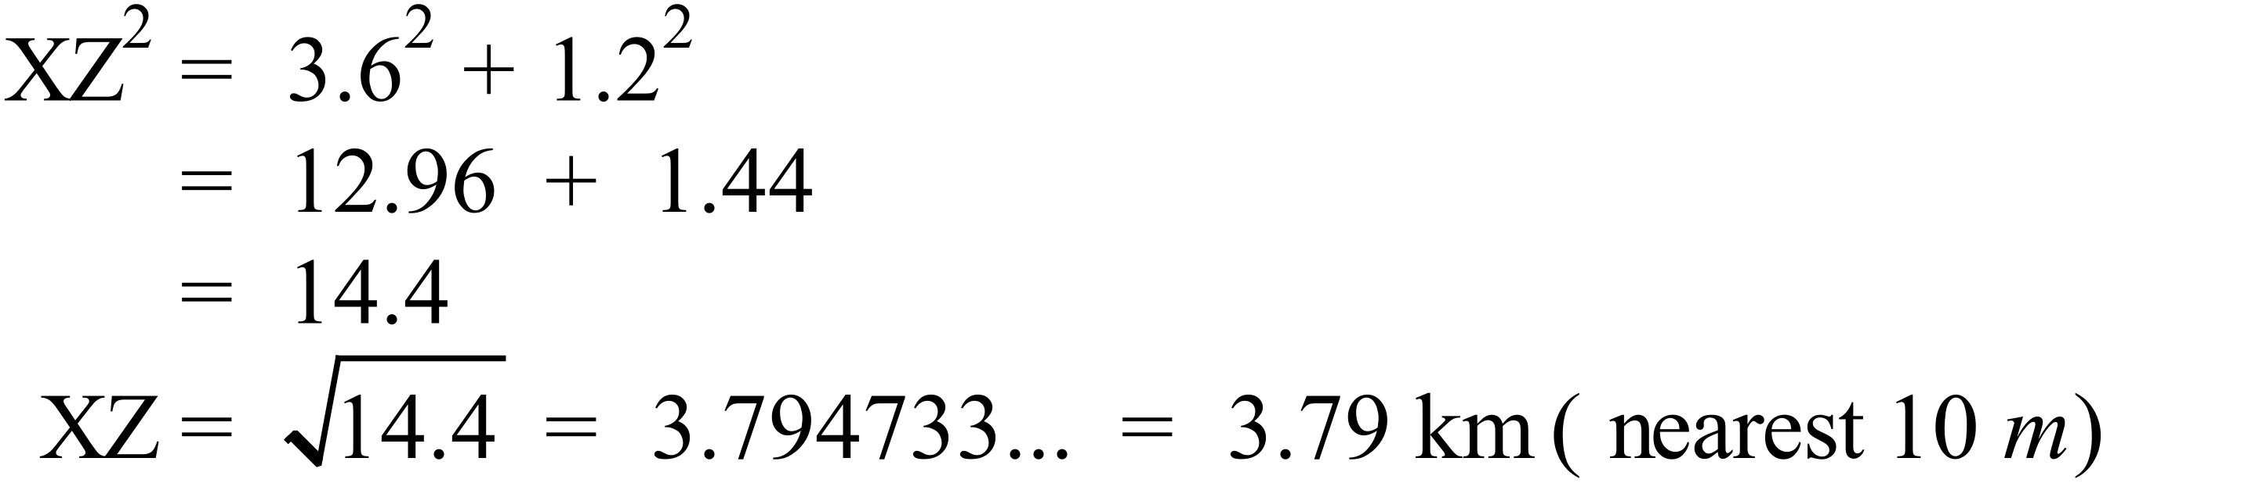 | B
 | 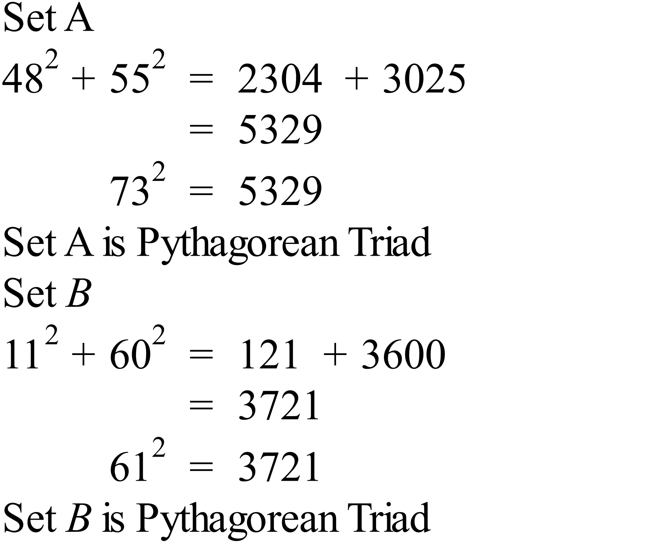 | A
 | 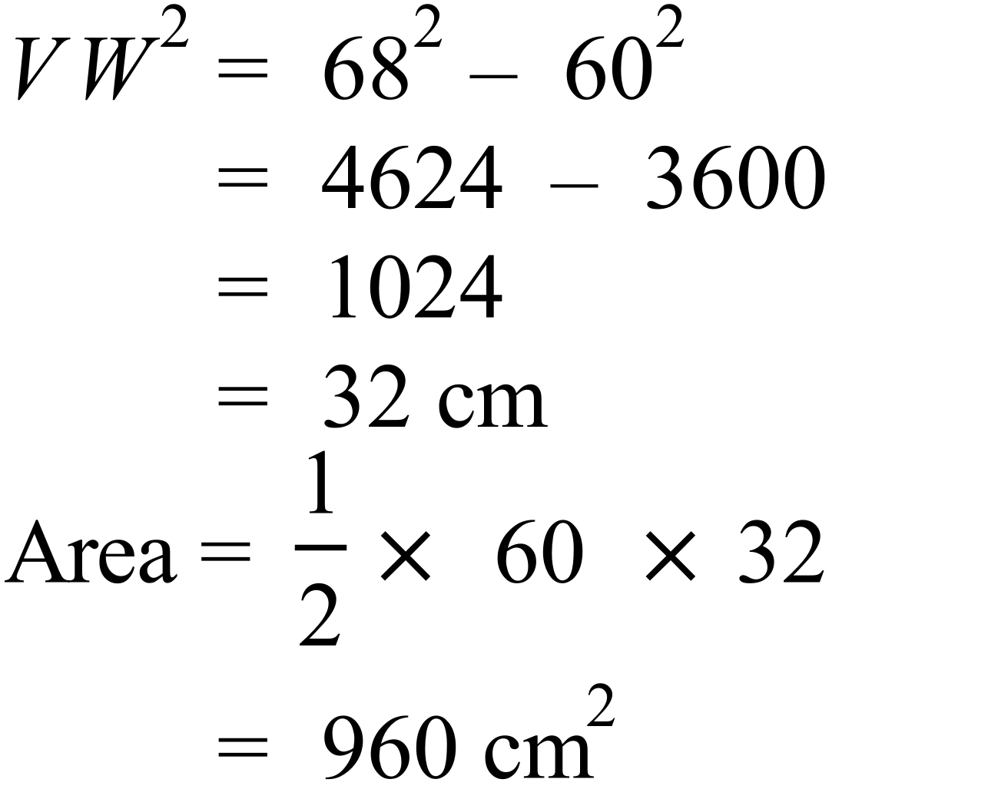 | D
 | 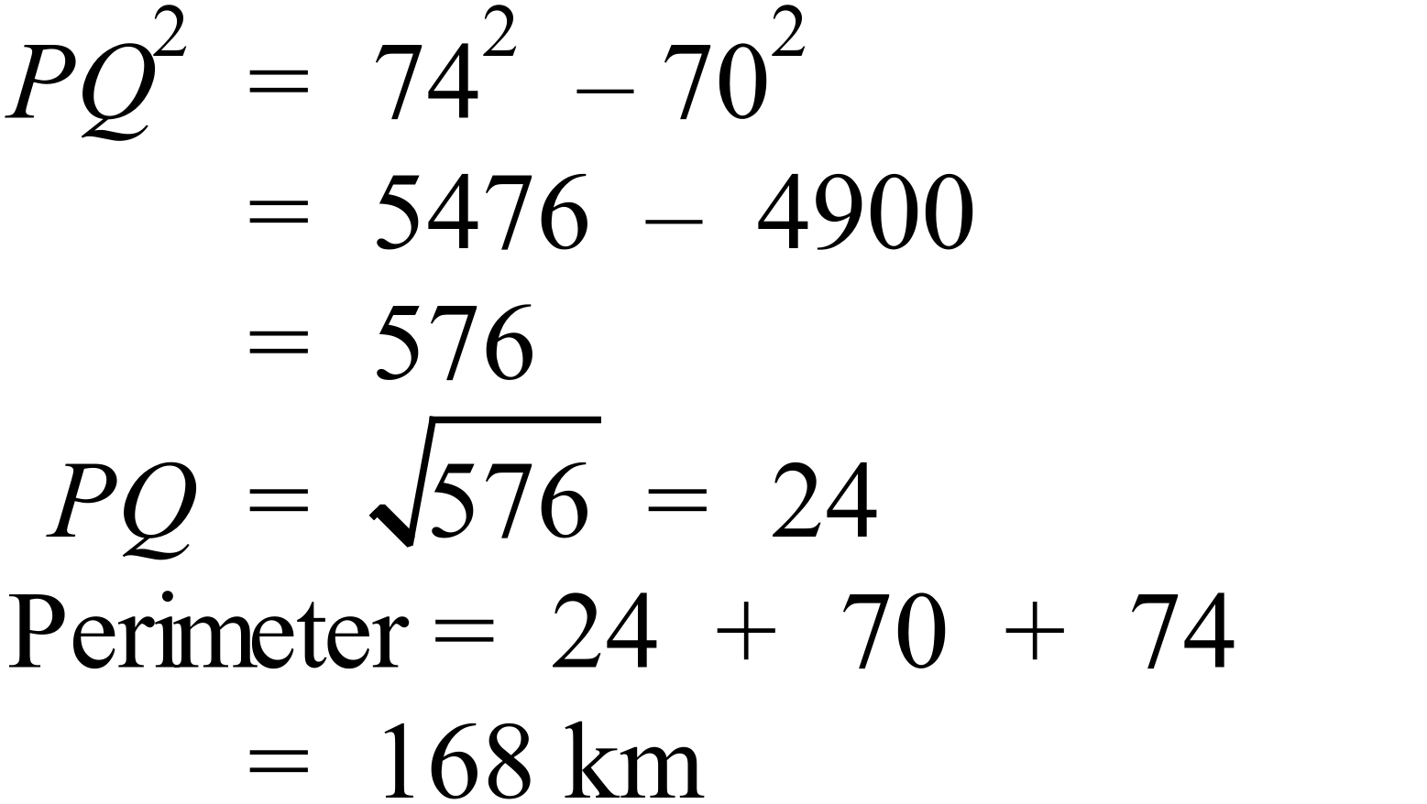 | D
 | 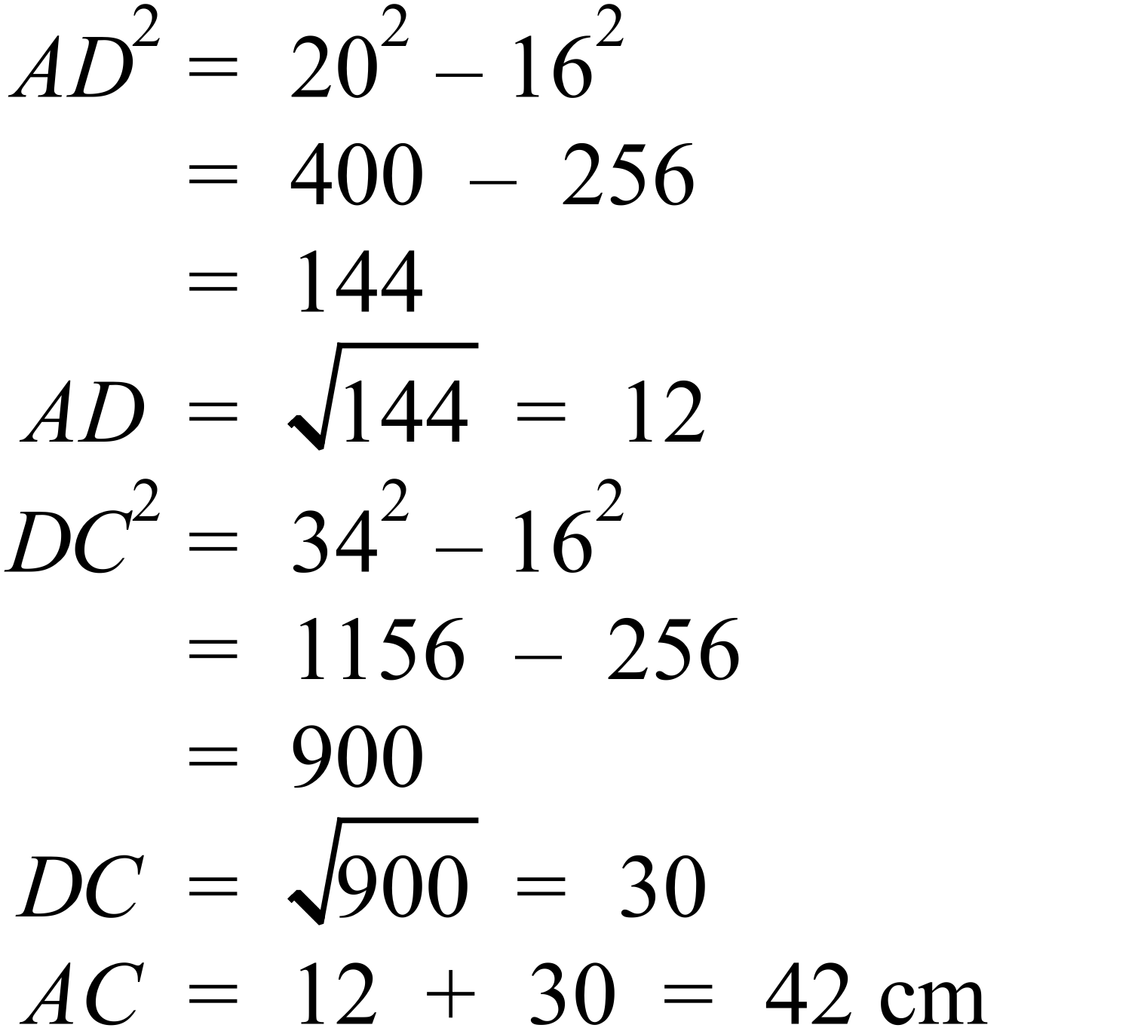 | C
 | 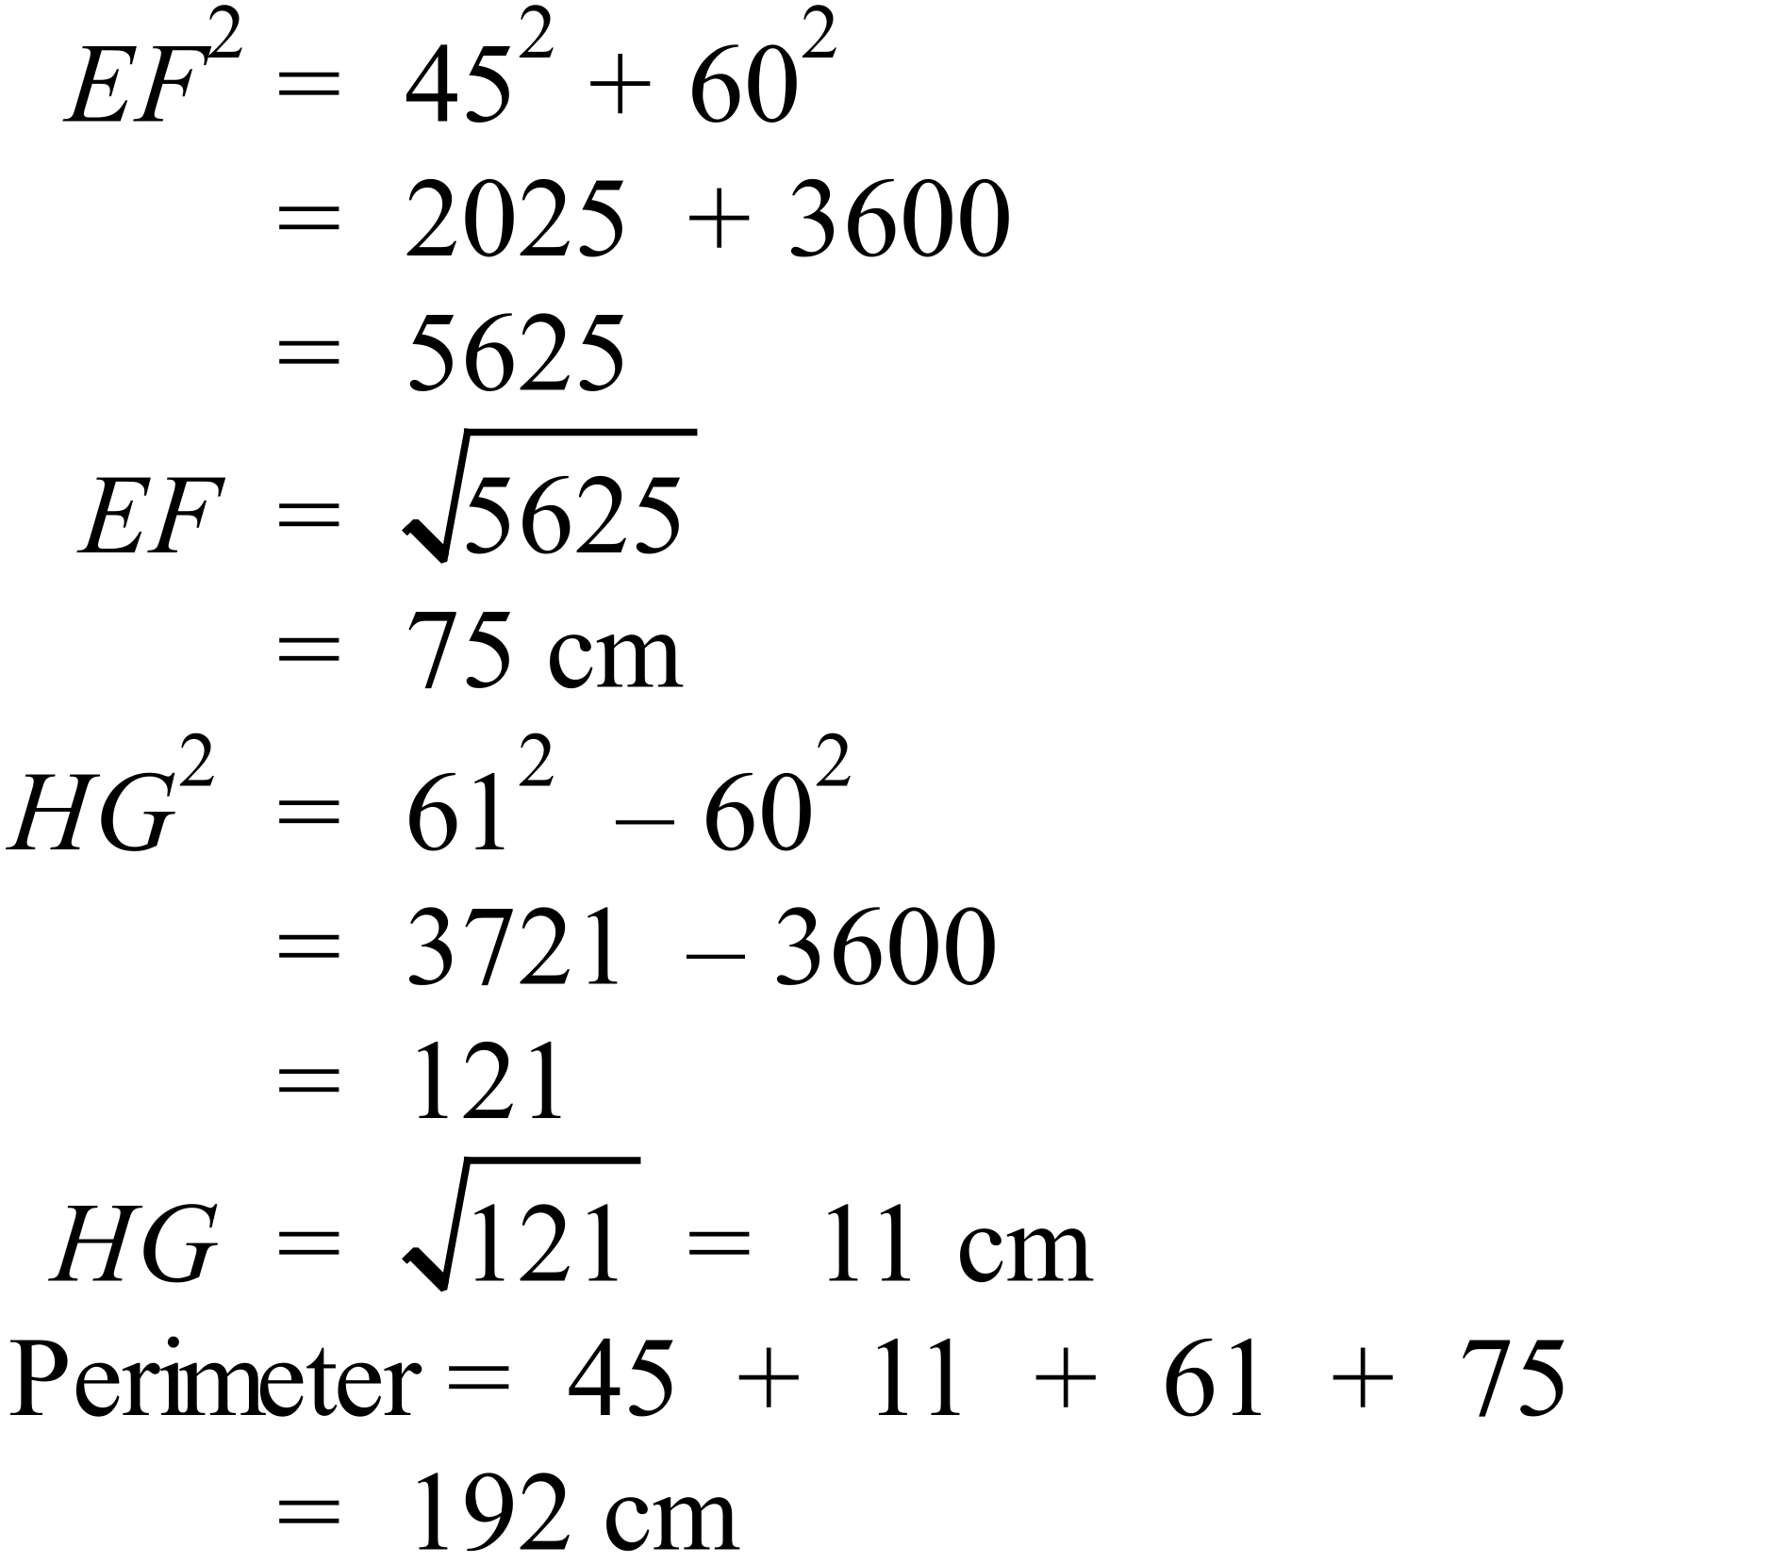 | B
 | 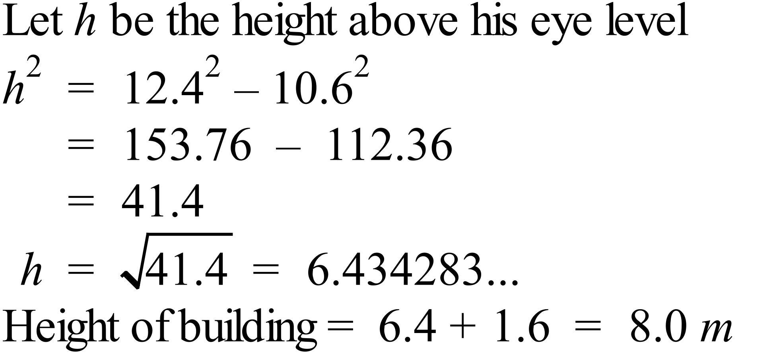 | D

School Name
Mathematics 2017
Multiple Choice Answer Sheet
Pythagoras Theorem
Name _____________________________________________
Completely fill the response oval representing the most correct answer.
1. A B C D
2. A B C D
3. A B C D
4. A B C D
5. A B C D
6. A B C D
7. A B C D
8. A B C D
9. A B C D
10. A B C D
11. A B C D
12. A B C D
13. A B C D
14. A B C D
15. A B C D

